PROJECT ON ONLINE PORTAL FOR SURVEY & POLLING SYSTEM

REPORT OF MAJOR PROJECT SUBMITTED FOR

FULFILLMENT OF THE DEGREE OF

BACHELORS IN CAMS

# Name: N.Vijay Mohan

Roll No.: 194365

# Name: V. Bhargavi

Roll No.: 194341

# Name: G. Lakshmi Durga

Roll No.: 194342

# **UNDER THE SUPERVISION OF**

Mr. GOPI

LECTURER (COMPUTER SCIENCE DEPT.)



AT

PB SIDDHARTHA COLLEGE OF ARTS AND SCIENCE,

VIJAYAWADA, KRISHNA, 520010.

PB SIDDHARTHA COLLEGE OF ARTS AND SCIENCE

VIJAYAWADA, 520010



# **CERTIFICATE**

The report of the Project titled Online Portal for Survey and Polling System submitted has been prepared under my supervision for the fulfilment of the requirements for CAMS degree in PB SIDDHARTHA COLLEGE OF ARTS AND SCIENCE. The report is hereby forwarded.

Guide:

Mrs. GOPI

Lecturer (Computer Science)

PBSC, Vijayawada

Countersigned by

……………………………………………

EXTERNAL EXAMINER

# **ACKNOWLEDGEMENT**

I express my sincere gratitude to LECTURER GOPI sir of Department of Computer Science PBSC, my project guide and for extending his valuable times for me to take up this problem as a project.

Date: __________ __________________

|  |  |  |  |  |  |
| --- | --- | --- | --- | --- | --- |
| Contents    TOPICS | |  |  |  | PAGE |
| NO.  1. | Abstract |  |  |  | 1 |
| 2. | Introduction |  |  |  | 2 |
| 3. | Purpose |  |  |  | 2 |
| 4. | Modules |  |  |  | 3 |
| 5. | Aims and Objectives |  |  |  | 3 |
| 6. | Product Prospective |  |  |  | 4 |
| 7. | Feasibility Study |  |  |  | 5 |
| 8. | Database Tables |  |  |  | 7 |
| 9. ERD Diagram | |  |  |  | 10 |
| 10. DFD Diagram | |  |  |  | 11 |
| 11. Use Case Diagram | |  |  |  | 12 |
| 12. Source Codes with Screenshots | |  |  |  | 13 |
| 13. Features of Project | |  |  |  | 62 |
| 14. Future Scope and Conclusion | |  |  |  | 62 |
| 15. Conclusion and Bibliography | |  |  |  | 63 |

## Abstract

Online Portal for Survey and Polling System is a project which aims in developing a computerized system to maintain all the decision making processes taken inside a college .This project has many features which are generally not available in normal systems like facility of admin login through which the admin can monitor the whole system . It has also a facility where admin after logging in the account can monitor the whole system and also the members can request the admin to create a new polling event if needed by filling event request section. The admin after logging into his account i.e. admin account can generate reports regarding the polling results such as winner declaration as well as percentages of candidates results.

Overall this project of ours is being developed to help the college management as well as staff of college to take decisions easily and also reduce the human efforts.

Introduction

The proposed project is a smart survey and polling system that provides the college management an easy way of maintaining the whole decision making and survey system in an easy manner. It overcomes the problems of unnecessary time consuming tasks. Hence this project offers a web based system where admin can view various instances and control them. If the event is available then the allowed members who can participate in that specific polling or survey can give their decision in that specific time given by the admin. The participants i.e. the candidates of the events can also add their images and their audio video files for the audience who will vote them, this will help the members to make decision and select candidates easily. Admin can update or delete events anytime. There are many other features also available.

## Purpose

The purpose of this document is to describe the functionality and specifications of the design of application on php language. The expected audiences of this document are the developers and users of the application. This will allow users to access the polling and survey system from anywhere in this world.

## Modules

Admin:

Admin gets login by valid username and password. Admin can see the request send by the students or faculty. Admin can also create events manually. Admin can view all the details and can allow special user to create event. Admin verifies the details of the members and declares the result.

Student:

The student portion will allow students to participate in the polling system for election of the common college election for the college welfare such as selecting class representative, college general secretary etc. they are also allowed to participate in the college survey and decision making system for the college.

Faculty:

The faculties’ portion will also work in the same process but will allow the faculty members only in the survey and college committee selection procedures.

Admin Panel

Result Board

## Project Aims and Objectives

* Automation polling and survey system
* Online polling
* A database table to check the authenticity of the participants
* Simple database table to keep record of surveys and polls
* Providing some extra smooth facilities in the system which are not available easily manually.
* Reducing paper works as well as human efforts.

Advantages

It saves management time in task of decision making.

The system provides a graphical view and an interactive look.

The whole system is controlled by the admin.

It excludes the need of human efforts.

The system generates online results of surveys and polling.

Cost-effective.

Disadvantages

It requires an internet connection.

It requires large database.

## Product Perspective

Online Portal for Polling and Survey System is an application which refers to polling or survey systems which are generally small or medium in size. It is used by colleges to manage the decision making procedures using a computerized system where the management can record various issue of polling and survey like candidate details, participant details etc.

Student and faculty maintenance modules are also included in this system which would keep track of the members using the system and also a detailed description about the event. With this computerized system there will be no illegal member will be able to participate which generally happens when a non-computerized system is used.

In addition, admin, the user is able to generate different kinds of reports like lists of members registered, list of events, issue of results, creating events etc.

All these modules are able to help admin to manage the polling or survey with more convenience and in a more efficient way as compared to systems which are not computerized.

## FEASIBILITY STUDY

After identifying the scope of the project, the feasibility study is needed to be carried out. It is basically keeping the following points in mind.

Building the software for meeting the scope: This software has met the scope. As there is no data involved in the system, processing on the file, and the behaviour of this project is already identified and bundled I quantitative manner.

The processing of this software is very simple as it has been designed in php and it has been well divided into several functions according to the need.

Technically feasible: This software is very much technically feasible. This software is very much concerned with specifying equipment and the software will successfully satisfy almost all the user requirements. The technical need for this system may vary considerably but might include:

1. The facility to produce output in a given time.
2. Response time under certain conditions.
3. Ability to process a file at a particular speed.

Therefore, the basic input/output of all files is identified. So, the project can easily be build up and it will also be technically feasible.

State of Art: The project is very much within the state of art since the project is a WINDOWS based; it uses very modern and common technique.

Beside it is very much modern and user friendly. It also works as middleware i.e. only in between the user and the file. So, it is completely a state of art project.

Financially Feasible: The project is very much financially feasible. The implementation and development cost of this software under the reach of any college.

Moreover, it requires some training for the use. So, training cost can be neglected and the resources of this software are very much available. It also reduces the labour and extra cost to be paid for labour. So indeed, it is financially feasible.

Resources: As motioned earlier that the resources are easily available and the cost of training is almost negligible. Sometimes situations may arise when it may not be so much easy. For a person completely unaware of using a computer system could result in a training cost or for a very small organization the purchase of a computer, instalment of the system and other charges may lead to a difficult matter.

Touching User’s mind: The basic features of this software are simplicity, easily understandable, easily applicable. If this type of software is a new experience for the user is certainly going to be like it.

Project Category: PHP Online Portal for Survey and Polling System

Available Technologies:

Languages: HTML 5, PHP 3, Bootstrap

RDBMS: Online MySQL Development Platform: Notepad ++

Tools Used:

Editor Used: Notepad ++ Operating System: Windows 2007 Hardware Used:

Processor: Intel core i3

RAM: 2GB

Hard Disk: 500GB

Database tables

Admin:

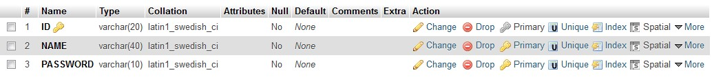

Cadidates:

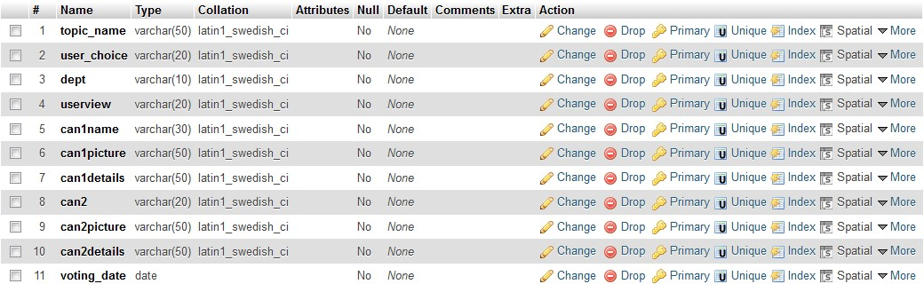

Canvote:

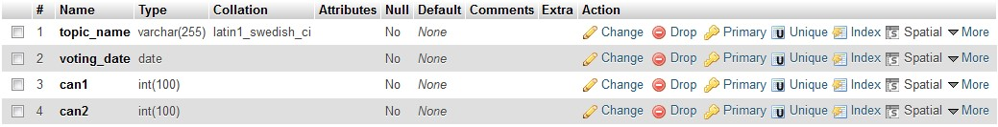

Decision_making:

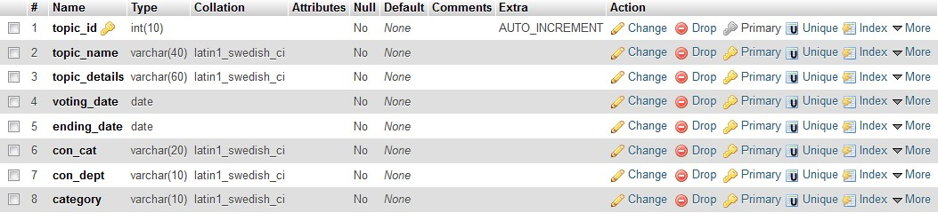

Faculty_master_registration:

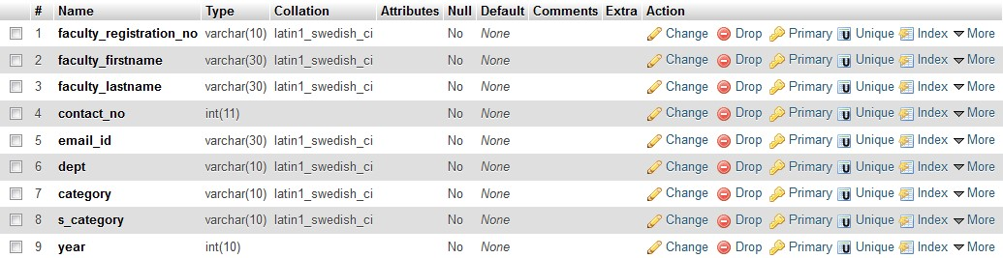

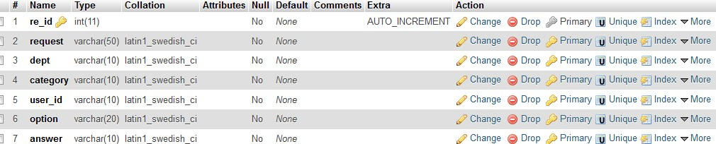

Remark:

request:

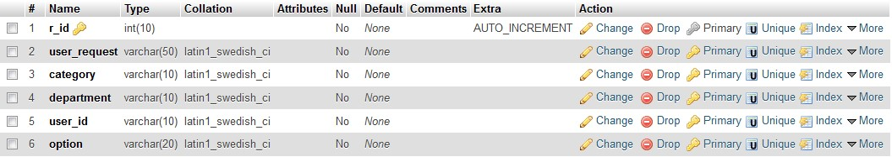

Student_master_registration:

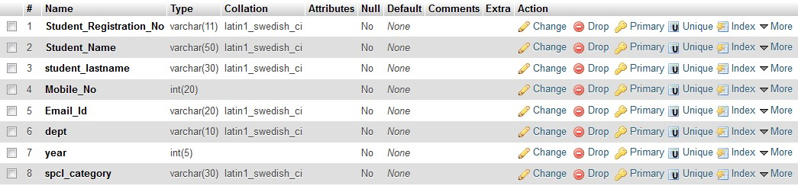

Winner:

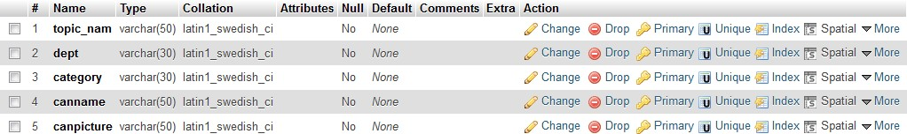

Video_upload:

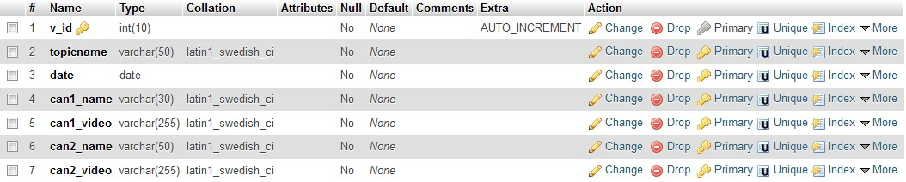

## ERD

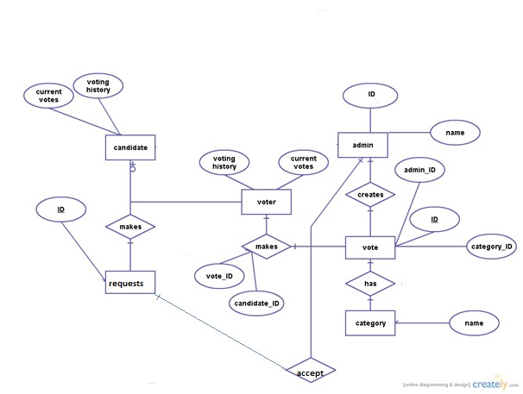

DFD

Level 0:

Level 1:

E

-

voting

Management

System

Voter

Admin

voter

Voting

Voter details

and vote

candidate

Nomination

process

Candidate

details

Enrolled

candidates

Enrolled candidates

votes

Candidate details

result

admin

winner

Calculate vote

USE CASE DIAGRAM

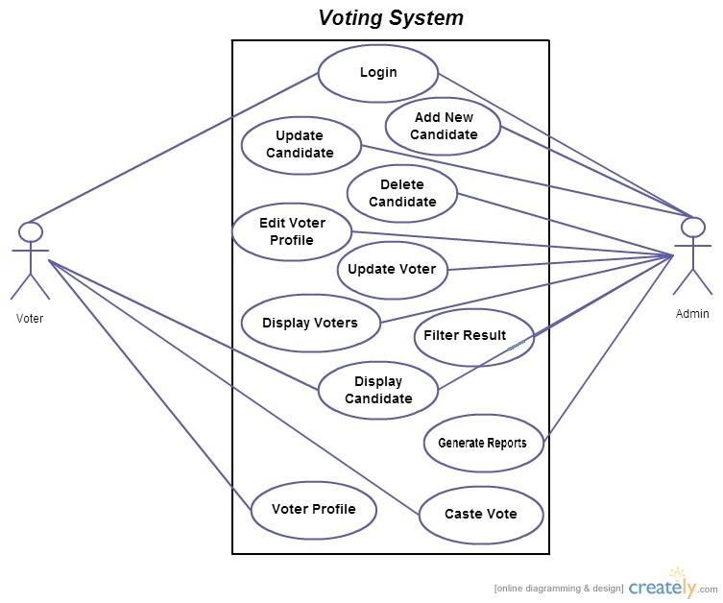

Source Codes

INDEX.HTML



<!doctype html>

<html>

<head>

<meta charset="UTF-8">

<title>online portal</title>

<meta name="viewport" content="width=device-width, initial-scale=1, shrink-tofit=no">

<link rel="stylesheet" href="css/bootstrap.min.css" />

<link rel="stylesheet" href="css/bootstrap.css" />

<link rel="stylesheet" href="css/bootstrap-grid.css" />

<link rel="stylesheet" href="css/bootstrap-grid.min.css" />

<link rel="stylesheet" href="css/bootstrap.min.css" />

<link rel="stylesheet" href="css/bootstrap-reboot.css" />

<link rel="stylesheet" href="css/bootstrap-reboot.min.css" />

<link rel="stylesheet" type="text/css" href="style.css" />

</head>

<body>

<div id="wrapper">

<div id="header">

<div id="main">

<nav class="navbar navbar-expand-lg navbar-light bg-light">

<a class="navbar-brand" href="#">

<img src="img/logo.png" width="80" height="30" class="d-inline-block align-top" alt="">

</a>

<button class="navbar-toggler" type="button" data-toggle="collapse" datatarget="#navbarSupportedContent" aria-controls="navbarSupportedContent" ariaexpanded="false" aria-label="Toggle navigation">

<span class="navbar-toggler-icon"></span>

</button>

<div class="collapse navbar-collapse" id="navbarSupportedContent">

<ul class="navbar-nav mr-auto">

<li class="nav-item active">

<a class="nav-link" href="#">Home <span class="sr-only">(current)</span></a>

</li>

<li class="nav-item">

<a class="nav-link" href="status.php">status</a>

</li>

<li class="nav-item">

<a class="nav-link" href="contactus.html">contact us</a>

</li>

</ul>

</div>

</nav>

<div class="container">

<div class="row align-items-center">

<div class="col-6 mx-auto col-md-6 order-md-2">

<img class="img-fluid mb-3 mb-md-0" src="img/v1.jpg" alt="" width="1024" height="860">

</div>

<div class="col-md-6 order-md-1 text-center text-md-left pr-md-5">

<h2 class="mb-3 bd-text-purple-bright">Online Portal For Survey And Polling

System</h2>

<hr class="half-rule">

<center> <a class="btn btn-outline-primary" href="user.html">click here</a></center>

</div>

</div>

</div>

</div>

</div>

</div>

<script src="js/jquery.js"></script>

<script src="js/bootstrap.js"></script>

<script src="js/bootstrap.bundle.js"></script>

<script src="js/bootstrap.bundle.min.js"></script>

<script src="js/bootstrap.min.js"></script>

</body>

</html>

USER.HTML

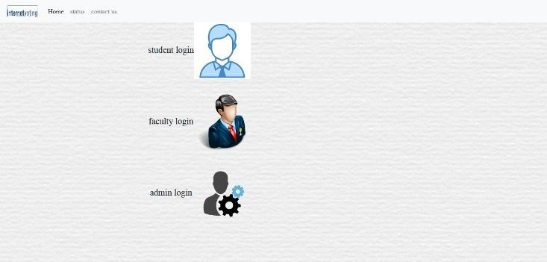

<!doctype html>

<html>

<head>

<meta charset="UTF-8">

<title>online portal</title>

<meta name="viewport" content="width=device-width, initial-scale=1, shrink-tofit=no">

<link rel="stylesheet" href="css/bootstrap.min.css" />

<link rel="stylesheet" href="css/bootstrap.css" />

<link rel="stylesheet" href="css/bootstrap-grid.css" />

<link rel="stylesheet" href="css/bootstrap-grid.min.css" />

<link rel="stylesheet" href="css/bootstrap.min.css" />

<link rel="stylesheet" href="css/bootstrap-reboot.css" />

<link rel="stylesheet" href="css/bootstrap-reboot.min.css" />

<link rel="stylesheet" type="text/css" href="style.css" />

</head>

<body>

<div id="wrapper">

<div id="header">

<div id="main">

<nav class="navbar navbar-expand-lg navbar-light bg-light">

<a class="navbar-brand" href="index.html">

<img src="img/logo.png" width="80" height="30" class="d-inline-block align-top" alt="">

</a>

<button class="navbar-toggler" type="button" data-toggle="collapse" datatarget="#navbarSupportedContent" aria-controls="navbarSupportedContent" ariaexpanded="false" aria-label="Toggle navigation">

<span class="navbar-toggler-icon"></span>

</button>

<div class="collapse navbar-collapse" id="navbarSupportedContent">

<ul class="navbar-nav mr-auto">

<li class="nav-item active">

<a class="nav-link" href="#">Home <span class="sr-only">(current)</span></a>

</li>

<li class="nav-item">

<a class="nav-link" href="status.php">status</a>

</li>

<li class="nav-item">

<a class="nav-link" href="contactus.html">contact us</a>

</li>

</ul>

</div>

</nav>

<div id="menu"></div>

<div id="content">

<div class="container">

<DIV CLASS="ROW ALIGN-ITEMS-CENTER">

<div class="col-md-8 col-md-pull-4">

<h1 class="mb-3">student login<a href="studentlogin.php"><img src="img/sstd.png" alt="" height="30%" width="20%"></a></h1>

</div>

<div class="col-md-8 col-md-pull-4">

<h1 class="mb-3">faculty login<a href="facultylogin.php"><img src="img/fac.png" alt="" height="30%" width="20%"></a></h1>

</div>

<div class="col-md-8 col-md-pull-4">

<h1 class="mb-3">admin login<a href="adminlogin.php"><img

src="img/admon.png" alt="" height="30%" width="20%"></a></h1>

</div>

</div>

</div>

</div>

<script src="js/jquery.js"></script>

<script src="js/bootstrap.js"></script>

<script src="js/bootstrap.bundle.js"></script>

<script src="js/bootstrap.bundle.min.js"></script>

<script src="js/bootstrap.min.js"></script>

<div id="comment"></div>

<div id="footer"></div>

</div>

</body>

</html>

ADMIN.PHP

<!

doctype html

>

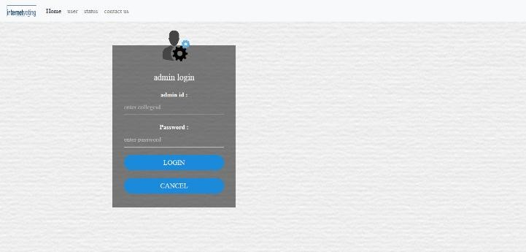

<html>

<head>

<meta charset="UTF-8">

<title>online portal</title>

<meta name="viewport" content="width=device-width, initial-scale=1, shrink-tofit=no">

<link rel="stylesheet" href="css/bootstrap.min.css" />

<link rel="stylesheet" href="css/bootstrap.css" />

<link rel="stylesheet" href="css/bootstrap-grid.css" />

<link rel="stylesheet" href="css/bootstrap-grid.min.css" />

<link rel="stylesheet" href="css/bootstrap.min.css" />

<link rel="stylesheet" href="css/bootstrap-reboot.css" />

<link rel="stylesheet" href="css/bootstrap-reboot.min.css" />

<link rel="stylesheet" type="text/css" href="style.css" />

</head>

<body>

<form action="checkaduser.php" method="post">

<div id="wrapper">

<div id="header">

<div id="main">

<nav class="navbar navbar-expand-lg navbar-light bg-light">

<a class="navbar-brand" href="index.html">

<img src="img/logo.png" width="80" height="30" class="d-inline-block align-top" alt=""> </a>

<button class="navbar-toggler" type="button" data-toggle="collapse" datatarget="#navbarSupportedContent" aria-controls="navbarSupportedContent" ariaexpanded="false" aria-label="Toggle navigation">

<span class="navbar-toggler-icon"></span>

</button>

<div class="collapse navbar-collapse" id="navbarSupportedContent">

<ul class="navbar-nav mr-auto">

<li class="nav-item active">

<a class="nav-link" href="#">Home <span class="sr-only">(current)</span></a>

</li>

<li class="nav-item">

<a class="nav-link" href="user.html">user</a>

</li>

<li class="nav-item">

<a class="nav-link" href="status.php">status</a>

</li>

<li class="nav-item">

<a class="nav-link" href="contactus.html">contact us</a>

</li>

</ul>

</div>

</nav>

<div id="menu"></div>

<div id="content">

<div class="hero">

<div class="container">

<div class="banner-content col-lg-7 col-md-12">

<div class="login-box">

<img src="img/admon.png" class="sstd">

<h1>admin login</h1>

<p>admin id :</p>

<INPUT TYPE="TEXT" NAME="UID" ID="ud" placeholder="enter collegeid">

<p>Password :</p>

<INPUT TYPE ="PASSWORD" NAME="PWD" ID="pd" placeholder="enter password">

<INPUT TYPE ="submit" VALUE="LOGIN">

<INPUT TYPE ="reset" VALUE="CANCEL">

</form>

</div>

</div>

</div>

</div>

</div>

</div>

<script src="js/jquery.js"></script>

<script src="js/bootstrap.js"></script>

<script src="js/bootstrap.bundle.js"></script>

<script src="js/bootstrap.bundle.min.js"></script>

<script src="js/bootstrap.min.js"></script>

<div id="comment"></div>

<div id="footer"></div>

</div>

</form>

</body>

</html>

ADHOME.PHP

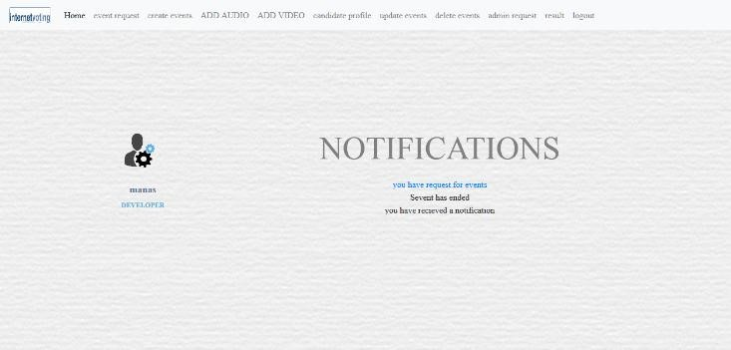

<!doctype html>

<html>

<head>

<meta charset="UTF-8">

<title>online portal</title>

<meta name="viewport" content="width=device-width, initial-scale=1, shrink-tofit=no">

<link rel="stylesheet" href="css/bootstrap.min.css" />

<link rel="stylesheet" href="css/bootstrap.css" />

<link rel="stylesheet" href="css/bootstrap-grid.css" />

<link rel="stylesheet" href="css/bootstrap-grid.min.css" />

<link rel="stylesheet" href="css/bootstrap.min.css" />

<link rel="stylesheet" type="text/css" href="style.css" />

<link rel="stylesheet" type="text/css" href="STYLE1.CSS" />

</head>

<body>

<div id="wrapper">

<div id="main">

<nav class="navbar navbar-expand-lg navbar-light bg-light navbar-left">

<a class="navbar-brand" href="#">

<img src="img/logo.png" width="80" height="30" class="d-inline-block align-top" alt="">

</a>

<button class="navbar-toggler" type="button" data-toggle="collapse" datatarget="#navbarSupportedContent" aria-controls="navbarSupportedContent" ariaexpanded="false" aria-label="Toggle navigation">

<span class="navbar-toggler-icon"></span>

</button>

<div class="collapse navbar-collapse" id="navbarSupportedContent">

<ul class="navbar-nav mr-auto">

<li class="nav-item active">

<a class="nav-link" href="#">Home <span class="sr-only">(current)</span></a>

</li>

<li class="nav-item">

<a class="nav-link" href="eventrequest.php">event request</a>

</li>

<li class="nav-item">

<a class="nav-link" href="CHOICECREATE.PHP">create events</a>

</li>

<li class="nav-item">

<a class="nav-link" href="adaudio.php">ADD AUDIO</a>

</li>

<li class="nav-item">

<a class="nav-link" href="advideo.php">ADD VIDEO</a>

</li>

<li class="nav-item">

<a class="nav-link" href="canpro.php">candidate profile</a>

</li>

<li class="nav-item">

<a class="nav-link" href="updateevent.php">update events</a>

</li>

<li class="nav-item">

<a class="nav-link" href="deleteevent.php">delete events</a>

</li>

<li class="nav-item">

<a class="nav-link" href="adreq.php">admin request</a>

</li>

<li class="nav-item">

<a class="nav-link" href="res.php">result</a>

</li>

<li class="nav-item">

<a class="nav-link" href="logout.php">logout</a>

</li>

</ul>

</div>

</nav>

<!--<nav>

<a href="index.html"><img src="img/logo.png" width="200" height="70" /></a>

<ul><font color="black">

<li> <a href="adhome.php">HOME</a></li>

<li><a href="eventmanage.php">manage events</a></li>

<li><a href="adaudio.php">add audio</a></li>

<li><a href="advideo.php">add video</a></li>

<li><a href="canli.php">CANDIDATE LIST</a></li>

<li><a href="canpro.php">CANDIDATE PROFILE</a></li>

<li><a href="updateevent.php">update event</a></li>

<li><a href="upchoice.php">DELETE USER</a></li>

<li><a href="adre.php">ADMIN REQUEST</a></li>

<li><a href="res.php">RESULT</a></li>

<li><a href="logout.php">LOG OUT</a></li>

</li>

</ul>

</nav>-->

<div id="menu"></div>

<div id="content">

<div class="hero">

<div class="container">

<div class="row profile">

<div class="col-md-3">

<div class="profile-slider">

<div class="profile-user-pic">

<img src="img/admon.png" class="imgr-responsive img-circle" height="80%" width="80%">

</div>

<div class="profile-user-title">

<div class="profile-user-name">

<?php

include('connection.php');

SESSION_START();

$user=$_SESSION["uid"];

$res=mysql_query("select * from admin WHERE ID='$user'");

while($row=mysql_fetch_array($res))

{

$fn=$row['NAME'];

echo $fn;

}

?>

</div>

<div class="profile-user-job">

developer

</div>

</div>

</div>

</div>

<div class="col-md-9">

<H2>NOTIFICATIONS</H2>

<center>

<?PHP

$res=mysql_query("select count(*) as counts from request" );

while($row=mysql_fetch_array($res))

{

$c=$row['counts']; if($c!=0)

{

?>

<a href="eventrequest.php"><?php echo "you have request for events"."<br>"; ?> </a>

<?php } else

{

}

}

$res1=mysql_query("select topic_name,count(*) as count from votend");

while($row1=mysql_fetch_array($res1))

{

$c=$row1['count']; $t=$row1['topic_name'];

if($c!=0)

{

|  |  |  |
| --- | --- | --- |
|  |  | echo $t."event has ended"."<br>"; |
|  |  | } |
|  |  | else |
| } |  | { |
|  |  | } |
| adminnotify"); |  | $res2=mysql_query("select count(*) as count from |
|  |  | while($row2=mysql_fetch_array($res2)) |
|  |  | { |
|  |  | $c=$row2['count']; |
|  |  | if($c!=0) |
|  |  | { |
|  |  | echo "you have recieved a notification"."<br>"; |
|  |  | } |
|  |  | else |
| } |  | { |
| ?> |  | } |
|  | </center> | |
| </div>  </div> |  | |
| </div> |  | |

</div>

</div>

</div>

</div>

</div>

</div>

<script src="js/jquery.js"></script>

<script src="js/bootstrap.js"></script>

<script src="js/bootstrap.bundle.js"></script>

<script src="js/bootstrap.bundle.min.js"></script>

<script src="js/bootstrap.min.js"></script>

</body>

</html>

EVENTREQ.PHP

<!

doctype html

>

<

html

>

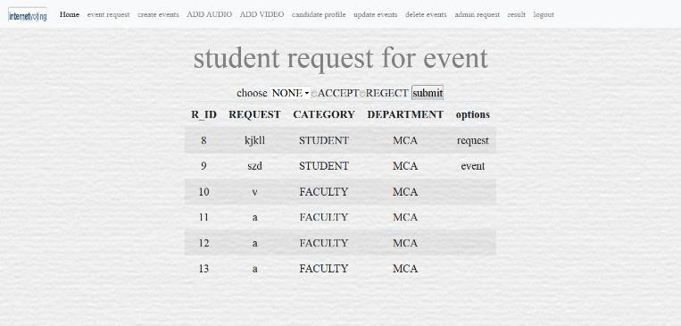

<head>

<meta charset="UTF-8">

<title>online portal</title>

<meta name="viewport" content="width=device-width, initial-scale=1, shrink-tofit=no">

<link rel="stylesheet" href="css/bootstrap.min.css" />

<link rel="stylesheet" href="css/bootstrap.css" />

<link rel="stylesheet" href="css/bootstrap-grid.css" />

<link rel="stylesheet" href="css/bootstrap-grid.min.css" />

<link rel="stylesheet" href="css/bootstrap.min.css" />

<link rel="stylesheet" type="text/css" href="style.css" />

<link rel="stylesheet" type="text/css" href="STYLE1.CSS" />

</head>

<body>

<FORM ACTION="decsub.php" method="post">

<div id="wrapper">

<div id="header">

<div id="main">

<nav class="navbar navbar-expand-lg navbar-light bg-light navbar-left">

<a class="navbar-brand" href="#">

<img src="img/logo.png" width="80" height="30" class="d-inline-block align-top" alt="">

</a>

<button class="navbar-toggler" type="button" data-toggle="collapse" datatarget="#navbarSupportedContent" aria-controls="navbarSupportedContent" ariaexpanded="false" aria-label="Toggle navigation">

<span class="navbar-toggler-icon"></span>

</button>

<div class="collapse navbar-collapse" id="navbarSupportedContent">

<ul class="navbar-nav mr-auto">

<li class="nav-item active">

<a class="nav-link" href="#">Home <span class="sr-only">(current)</span></a>

</li>

<li class="nav-item">

<a class="nav-link" href="res.php">event request</a>

</li>

<li class="nav-item">

<a class="nav-link" href="CHOICECREATE.PHP">create events</a>

</li>

<li class="nav-item">

<a class="nav-link" href="adaudio.php">ADD AUDIO</a>

</li>

<li class="nav-item">

<a class="nav-link" href="advideo.php">ADD VIDEO</a>

</li>

<li class="nav-item">

<a class="nav-link" href="canpro.php">candidate profile</a>

</li>

<li class="nav-item">

<a class="nav-link" href="updateevent.php">update events</a>

</li>

<li class="nav-item">

<a class="nav-link" href="deleteevent.php">delete events</a>

</li>

<li class="nav-item">

<a class="nav-link" href="adreq.php">admin request</a>

</li>

<li class="nav-item">

<a class="nav-link" href="res.php">result</a>

</li>

<li class="nav-item">

<a class="nav-link" href="logout.php">logout</a>

</li>

</ul>

</div>

</nav>

<div id="menu"></div>

<div id="content">

<div class="hero">

<DIV CLASS="CONTAINER">

<div class="row align-items-center">

<div class="col-lg-12 col-md-12">

<BR>

<CENTER>

<h2>student request for event</h2>

<TABLE CLASS="TABLE TABLE-STRIPED">

<TH><h1> choose <select name="tn">

<option value="NONE">NONE</OPTION>

<?PHP

include("connection.php");

$res=mysql_query("select user_request from request");

while($row=mysql_fetch_array($res))

{

$req=$row['user_request'];

?>

<option value="<?php echo $req ?>"><?php echo $req ?></option>

<?php }

?> </select><input type="radio" NAME="r1" value="ACCEPT">ACCEPT<INPUT

TYPE="RADIO" NAME="r1" value="REGECT">REGECT

<input type="submit" value="submit">

<table class="table table-striped">

<thead>

<tr>

<th scope="col">R_ID</th>

<th scope="col">REQUEST</th>

<th scope="col">CATEGORY</th>

<th scope="col">DEPARTMENT</th>

<th scope="col">options</th>

</tr>

</thead>

<tbody>

<?php

$res=mysql_query("select * from request");

while($row=mysql_fetch_array($res))

{

echo "<tr> <td> $row[r_id]</td>

<td>$row[user_request]</td>

<td>$row[category]</td>

<td>$row[department]</td>

<td>$row[option]</td>

</tr>";

}?>

</tbody>

</table>

</div>

</CENTER>

<table>

</div>

</div>

</div>

<div id="comment"></div>

<div id="footer"></div>

</div>

</body>

</html>

CREATEEVENT.PHP

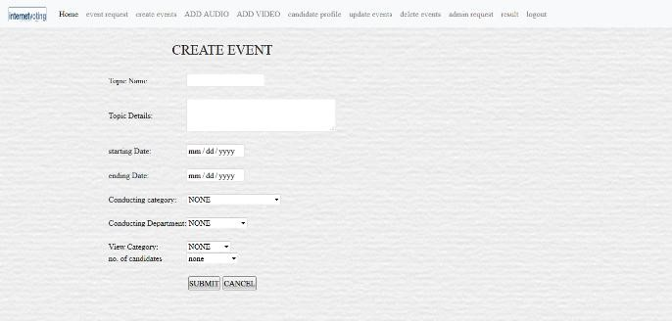

<!doctype html>

<html>

<head>

<meta charset="UTF-8">

<title>online portal</title>

<meta name="viewport" content="width=device-width, initial-scale=1, shrink-tofit=no">

<link rel="stylesheet" href="css/bootstrap.min.css" />

<link rel="stylesheet" href="css/bootstrap.css" />

<link rel="stylesheet" href="css/bootstrap-grid.css" />

<link rel="stylesheet" href="css/bootstrap-grid.min.css" />

<link rel="stylesheet" href="css/bootstrap.min.css" />

<link rel="stylesheet" type="text/css" href="style.css" />

<link rel="stylesheet" type="text/css" href="STYLE1.CSS" />

</head>

<body>

<div id="wrapper">

<div id="main">

<nav class="navbar navbar-expand-lg navbar-light bg-light navbar-left">

<a class="navbar-brand" href="#">

<img src="img/logo.png" width="80" height="30" class="d-inline-block align-top" alt="">

</a>

<button class="navbar-toggler" type="button" data-toggle="collapse" datatarget="#navbarSupportedContent" aria-controls="navbarSupportedContent" ariaexpanded="false" aria-label="Toggle navigation">

<span class="navbar-toggler-icon"></span>

</button>

<div class="collapse navbar-collapse" id="navbarSupportedContent">

<ul class="navbar-nav mr-auto">

<li class="nav-item active">

<a class="nav-link" href="#">Home <span class="sr-only">(current)</span></a>

</li>

<li class="nav-item">

<a class="nav-link" href="res.php">event request</a>

</li>

<li class="nav-item">

<a class="nav-link" href="CHOICECREATE.PHP">create events</a>

</li>

<li class="nav-item">

<a class="nav-link" href="adaudio.php">ADD AUDIO</a>

</li>

<li class="nav-item">

<a class="nav-link" href="advideo.php">ADD VIDEO</a>

</li>

<li class="nav-item">

<a class="nav-link" href="canpro.php">candidate profile</a>

</li>

<li class="nav-item">

<a class="nav-link" href="updatevent.php">update events</a>

</li>

<li class="nav-item">

<a class="nav-link" href="deleteevent.php">delete events</a>

</li>

<li class="nav-item">

<a class="nav-link" href="adreq.php">admin request</a>

</li>

<li class="nav-item">

<a class="nav-link" href="res.php">result</a>

</li>

<li class="nav-item">

<a class="nav-link" href="logout.php">logout</a>

</li>

</ul>

</div>

</nav>

</div>

<div class="hero">

<div class="container">

<div class="row align-items-center">

<div class="banner-content col-lg-12 col-md-12 COL-XS-12">

<?php session_start(); include("connection.php");

$user=$_SESSION["uid"];

?>

<H2><CENTER>-:CHOOSE YOUR OPTIONS:-</CENTER></H2>

</div>

<div class="col-lg-6 ">

<H1><A HREF="createvent.php">FOR ELECTION</A></H1>

</div>

<div class="col-lg-6">

<H1><A HREF="createvent2.php">FOR DECISSON MAKING</A></H1>

</DIV>

</DIV>

</DIV>

</DIV>

</FORM>

<script src="js/jquery.js"></script>

<script src="js/bootstrap.js"></script>

<script src="js/bootstrap.bundle.js"></script>

<script src="js/bootstrap.bundle.min.js"></script>

<script src="js/bootstrap.min.js"></script>

</body>

</html>

ADDCANDIDATES.PHP

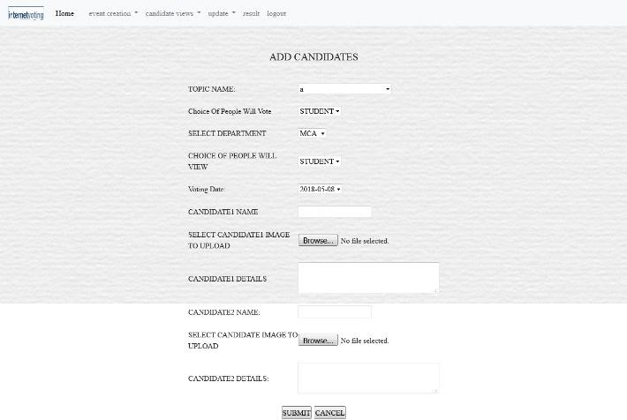

<!doctype html>

<html>

<head>

<meta charset="UTF-8">

<title>online portal</title>

<meta name="viewport" content="width=device-width, initial-scale=1, shrink-tofit=no">

<link rel="stylesheet" href="css/bootstrap.min.css" />

<link rel="stylesheet" href="css/bootstrap.css" />

<link rel="stylesheet" href="css/bootstrap-grid.css" />

<link rel="stylesheet" href="css/bootstrap-grid.min.css" />

<link rel="stylesheet" href="css/bootstrap.min.css" />

<link rel="stylesheet" type="text/css" href="style.css" />

<link rel="stylesheet" type="text/css" href="STYLE1.CSS" />

</head>

<body>

<FORM ACTION="insertcan5loop.php" enctype="multipart/form-data" method="post" onsubmit="return validate()">

<div id="main">

<nav class="navbar navbar-expand-lg navbar-light bg-light navbar-left">

<a class="navbar-brand" href="#">

<img src="img/logo.png" width="80" height="30" class="d-inline-block align-top" alt="">

</a>

<button class="navbar-toggler" type="button" data-toggle="collapse" datatarget="#navbarSupportedContent" aria-controls="navbarSupportedContent" ariaexpanded="false" aria-label="Toggle navigation">

<span class="navbar-toggler-icon"></span>

</button>

<div class="collapse navbar-collapse" id="navbarSupportedContent">

<ul class="navbar-nav mr-auto">

<li class="nav-item active">

<a class="nav-link" href="#">Home <span class="sr-only">(current)</span></a>

</li>

<li class="nav-item">

<a class="nav-link" href="eventrequest.php">event request</a>

</li>

<li class="nav-item">

<a class="nav-link" href="CHOICECREATE.PHP">create events</a>

</li>

<li class="nav-item">

<a class="nav-link" href="adaudio.php">ADD AUDIO</a>

</li>

<li class="nav-item">

<a class="nav-link" href="advideo.php">ADD VIDEO</a>

</li>

<li class="nav-item">

<a class="nav-link" href="canpro.php">candidate profile</a>

</li>

<li class="nav-item">

<a class="nav-link" href="updateevent.php">update events</a>

</li>

<li class="nav-item">

<a class="nav-link" href="deleteevent.php">delete events</a>

</li>

<li class="nav-item">

<a class="nav-link" href="adreq.php">admin request</a>

</li>

<li class="nav-item">

<a class="nav-link" href="res.php">result</a>

</li>

<li class="nav-item">

<a class="nav-link" href="logout.php">logout</a>

</li>

</ul>

</div>

</nav>

<div class="hero">

<!-- ADDING DETAILS FROM ADMIN FOR VOTE -->

<div class="container">

<div class="row align-items-center">

<div class="col-6 mx-auto col-md-6 order-md-2">

<BR><BR><BR><BR><BR><BR><BR><BR><BR><BR><BR><BR>

<BR><BR><BR>

<BR><BR><BR><BR><BR><BR><BR><BR><BR><BR>

<BR><BR><BR>

<BR><BR><BR><BR><BR><BR><BR><BR><BR><BR>

<BR><BR><BR>

<BR><BR><BR><BR><BR><BR><BR><BR><BR><BR>

<BR><BR><BR>

<H1>ADD CANDIDATES</H1>

<TABLE class="table">

<tbody>

<TR>

<TD><br>TOPIC NAME:</TD>

<TD><br><SELECT NAME="NM">

<?php

include("connection.php");

$sql="select topic_name from decission_making order by topic_id desc";

$res=mysql_query($sql); while($row=mysql_fetch_array($res))

{

$lq=$row['topic_name'];

?>

<option value="<?php echo $lq ?>"><?php echo $lq ?></option>

<?php

}

?>

</select></TD>

</TR>

<TR>

<TD><br>Choice Of People Will Vote</TD>

<TD><br><SELECT NAME="uu" ID="UV">

<?php

include("connection.php");

$sql="select con_cat from decission_making order by topic_id desc";

$res=mysql_query($sql); while($row=mysql_fetch_array($res))

{

$user=$row['con_cat'];

?>

<option value="<?php echo $user ?>"><?php echo $user ?></option>

<?php

}

?>

</select></TD>

</TR>

<TR>

<TD><br>SELECT DEPARTMENT</TD>

<TD><br><SELECT NAME="dd" ID="SD">

<?php

include("connection.php");

$sql="select con_dept from decission_making order by topic_id desc";

$res=mysql_query($sql); while($row=mysql_fetch_array($res))

{

$dd=$row['con_dept'];

?>

<option value="<?php echo $dd ?>"><?php echo $dd ?></option>

<?php

}

?></select></TD>

</TR>

<TR>

<TD><br>CHOICE OF PEOPLE WILL VIEW</TD>

<TD><br><SELECT NAME="pp" ID="SP">

<?php

include("connection.php");

$sql="select category from decission_making order by topic_id desc";

$res=mysql_query($sql); while($row=mysql_fetch_array($res))

{

$vuser=$row['category'];

?>

<option value="<?php echo $vuser ?>"><?php echo $vuser ?></option>

<?php

}

?>

</SELECT></TD>

</TR>

<TR>

<TD><br> Voting Date:</TD>

<TD><br><SELECT NAME="da" ID="DA">

<?php

include("connection.php");

$sql="select voting_date from decission_making order by topic_id desc";

$res=mysql_query($sql);

while($row=mysql_fetch_array($res))

{

$da=$row['voting_date'];

?>

<option value="<?php echo $da ?>"><?php echo $da ?></option>

<?php

}

?>

</SELECT></TD>

</TR>

<TR>

<TD><br>CANDIDATE1 NAME</TD>

<TD><br><input type="text" name="cnn1" id="CNN1"></TD> </TR>

<TR>

<td><br>SELECT CANDIDATE1 IMAGE TO UPLOAD</td>

<td><br><input type="file" name="file1" id="filee1"></td>

</TR>

<TR>

<TD><br>CANDIDATE1 DETAILS</TD>

<TD><br><TEXTAREA ROW="10" COLS="40" NAME="can1"

id="CAN1"></TEXTAREA></TD>

</TR>

<TR>

<TD><br>CANDIDATE2 NAME:</TD>

<TD><br><input type="text" name="cnn2" id="CNN2"></TD>

</TR>

<TR>

<td><br>SELECT CANDIDATE IMAGE TO UPLOAD</td>

<td><br><input type="file" name="file2" id="filee2"></td>

</TR>

<TR>

<TD><br>CANDIDATE2 DETAILS:</TD>

<TD><br><TEXTAREA ROW="10" COLS="40" NAME="can2"

id="CAN2"></TEXTAREA></TD>

</TR>

<TR>

<TD><br>CANDIDATE3 NAME</TD>

<TD><br><input type="text" name="cnn3" id="CNN1"></TD>

</TR>

<TR>

<td><br>SELECT CANDIDATE3 IMAGE TO UPLOAD</td>

<td><br><input type="file" name="file3" id="filee1"></td>

</TR>

<TR>

<TD><br>CANDIDATE3 DETAILS</TD>

<TD><br><TEXTAREA ROW="10" COLS="40" NAME="can3"

id="CAN1"></TEXTAREA></TD>

</TR>

<TR>

<TD><br>CANDIDATE4 NAME</TD>

<TD><br><input type="text" name="cnn4" id="CNN1"></TD>

</TR>

<TR>

<td><br>SELECT CANDIDATE4 IMAGE TO UPLOAD</td>

<td><br><input type="file" name="file4" id="filee1"></td>

</TR>

<TR>

<TD><br>CANDIDATE4 DETAILS</TD>

<TD><br><TEXTAREA ROW="10" COLS="40" NAME="can4"

id="CAN1"></TEXTAREA></TD>

</TR>

<TR>

<TD><br>CANDIDATE5 NAME</TD>

<TD><br><input type="text" name="cnn5" id="CNN1"></TD>

</TR><TR>

<td><br>SELECT CANDIDATE5 IMAGE TO UPLOAD</td> <td><br><input type="file" name="file5" id="filee1"></td>

</TR>

<TR>

<TD><br>CANDIDATE5 DETAILS</TD>

<TD><br><TEXTAREA ROW="10" COLS="40" NAME="can5"

id="CAN1"></TEXTAREA></TD>

</TR>

<TR>

<TD COLSPAN="2"><br><CENTER><INPUT TYPE ="submit" VALUE="SUBMIT">

<INPUT TYPE ="reset" VALUE="CANCEL"></CENTER></TD>

</TR>

</TABLE>

</center>

</div>

</div>

</div>

</div>

</div>

</div>

</div>

</div>

</div>

<script src="js/jquery.js"></script>

<script src="js/bootstrap.js"></script>

<script src="js/bootstrap.bundle.js"></script>

<script src="js/bootstrap.bundle.min.js"></script>

<script src="js/bootstrap.min.js"></script>

</body>

</html>

AUDIO.PHP

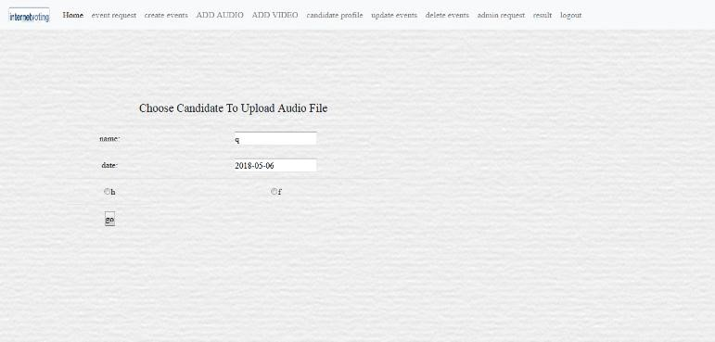

<!doctype html>

<html>

<head>

<meta charset="UTF-8">

<title>online portal</title>

<meta name="viewport" content="width=device-width, initial-scale=1, shrink-tofit=no">

<link rel="stylesheet" href="css/bootstrap.min.css" />

<link rel="stylesheet" href="css/bootstrap.css" />

<link rel="stylesheet" href="css/bootstrap-grid.css" />

<link rel="stylesheet" href="css/bootstrap-grid.min.css" />

<link rel="stylesheet" href="css/bootstrap.min.css" />

<link rel="stylesheet" type="text/css" href="style.css" />

</head>

<body>

<div id="wrapper">

<div id="main">

<nav class="navbar navbar-expand-lg navbar-light bg-light navbar-left">

<a class="navbar-brand" href="#">

<img src="img/logo.png" width="80" height="30" class="d-inline-block align-top" alt="">

</a>

<button class="navbar-toggler" type="button" data-toggle="collapse" datatarget="#navbarSupportedContent" aria-controls="navbarSupportedContent" ariaexpanded="false" aria-label="Toggle navigation">

<span class="navbar-toggler-icon"></span>

</button>

<div class="collapse navbar-collapse" id="navbarSupportedContent">

<ul class="navbar-nav mr-auto">

<li class="nav-item active">

<a class="nav-link" href="#">Home <span class="sr-only">(current)</span></a>

</li>

<li class="nav-item">

<a class="nav-link" href="eventrequest.php">event request</a>

</li>

<li class="nav-item">

<a class="nav-link" href="CHOICECREATE.PHP">create events</a>

</li>

<li class="nav-item">

<a class="nav-link" href="adaudio.php">ADD AUDIO</a>

</li>

<li class="nav-item">

<a class="nav-link" href="advideo.php">ADD VIDEO</a>

</li>

<li class="nav-item">

<a class="nav-link" href="canpro.php">candidate profile</a>

</li>

<li class="nav-item">

<a class="nav-link" href="updateevent.php">update events</a>

</li>

<li class="nav-item">

<a class="nav-link" href="deleteevent.php">delete events</a>

</li>

<li class="nav-item">

<a class="nav-link" href="adreq.php">admin request</a>

</li>

<li class="nav-item">

<a class="nav-link" href="res.php">result</a>

</li>

<li class="nav-item">

<a class="nav-link" href="logout.php">logout</a>

</li>

</ul>

</div>

</nav>

<FORM ACTION="chcanupau.php" method="post">

<div class="hero">

<div class="container">

<div class="row align-items-center">

<div class="col-md-4 col-md-push-8">

<img class="img-fluid mb-3 mb-md-0" src="img/CT.JPG" alt="" width="1024" height="860">

</DIV>

<div class="col-md-8 col-md-pull-4">

<TABLE><TR><TD>

select topic

<select name="tn">

<?php

include("connection.php");

$res=mysql_query("select topic_name from decission_making"); while($row=mysql_fetch_array($res))

{

$tonam=$row['topic_name'];

?>

<option value="<?php echo $tonam ?>"><?php echo $tonam ?></option>

<?php }

?>

</select><input type="submit" value="submit"></TD>

</TR>

</TABLE>

</div>

</DIV>

</DIV>

</DIV>

</DIV>

</DIV>

<script src="js/jquery.js"></script>

<script src="js/bootstrap.js"></script>

<script src="js/bootstrap.bundle.js"></script>

<script src="js/bootstrap.bundle.min.js"></script>

<script src="js/bootstrap.min.js"></script>

</body>

</html>

### CHCANPAU.PHP

<!doctype html>

<html>

<head>

<meta charset="UTF-8">

<title>online portal</title>

<meta name="viewport" content="width=device-width, initial-scale=1, shrink-tofit=no">

<link rel="stylesheet" href="css/bootstrap.min.css" />

<link rel="stylesheet" href="css/bootstrap.css" />

<link rel="stylesheet" href="css/bootstrap-grid.css" />

<link rel="stylesheet" href="css/bootstrap-grid.min.css" />

<link rel="stylesheet" href="css/bootstrap.min.css" />

<link rel="stylesheet" type="text/css" href="style.css" />

</head>

<body>

<div id="wrapper">

<div id="main">

<nav class="navbar navbar-expand-lg navbar-light bg-light navbar-left">

<a class="navbar-brand" href="#">

<img src="img/logo.png" width="80" height="30" class="d-inline-block align-top" alt="">

</a>

<button class="navbar-toggler" type="button" data-toggle="collapse" datatarget="#navbarSupportedContent" aria-controls="navbarSupportedContent" ariaexpanded="false" aria-label="Toggle navigation">

<span class="navbar-toggler-icon"></span>

</button>

<div class="collapse navbar-collapse" id="navbarSupportedContent">

<ul class="navbar-nav mr-auto">

<li class="nav-item active">

<a class="nav-link" href="#">Home <span class="sr-only">(current)</span></a>

</li>

<li class="nav-item">

<a class="nav-link" href="eventrequest.php">event request</a>

</li>

<li class="nav-item">

<a class="nav-link" href="CHOICECREATE.PHP">create events</a>

</li>

<li class="nav-item">

<a class="nav-link" href="adaudio.php">ADD AUDIO</a>

</li>

<li class="nav-item">

<a class="nav-link" href="advideo.php">ADD VIDEO</a>

</li>

<li class="nav-item">

<a class="nav-link" href="canpro.php">candidate profile</a>

</li>

<li class="nav-item">

<a class="nav-link" href="updateevent.php">update events</a>

</li>

<li class="nav-item">

<a class="nav-link" href="deleteevent.php">delete events</a>

</li>

<li class="nav-item">

<a class="nav-link" href="adreq.php">admin request</a>

</li>

<li class="nav-item">

<a class="nav-link" href="res.php">result</a>

</li>

<li class="nav-item">

<a class="nav-link" href="logout.php">logout</a>

</li>

</ul>

</div>

</nav>

<form action="choicecheck.php" method="post" onsubmit="return validate()">

</DIV>

<div class="hero">

<div class="banner-content col-lg-7 col-md-12">

<h1>

choose candidate

</h1>

<TABLE>

<?php

session_start();

$tn=$_POST['tn'];

$_SESSION['tn']=$tn;

include("connection.php");

$sql="select * from candidates where topic_name='$tn'";

$res1=mysql_query("select * from candidates5 where topic_name='$tn'");

$res=mysql_query($sql);

while($row=mysql_fetch_array($res))

{

$tnam=$row['topic_name'];

$vt=$row['voting_date'];

$can1=$row['can1name'];

$can2=$row['can2'];

?>

name:<input type="text" value="<?php echo $tnam ?>">

date:<input type="text" value="<?php echo $vt ?>">

<input type="radio" name="c1" value="<?php echo $can1 ?>"><?php echo $can1 ?>

<input type="radio" name="c1" value="<?php echo $can2 ?>"><?php echo $can2 ?>

<input type="submit" value="go">

<?php }

if($res)

{

header('location:chan.php');

}

?>

</div>

</DIV>

<script src="js/jquery.js"></script>

<script src="js/bootstrap.js"></script>

<script src="js/bootstrap.bundle.js"></script>

<script src="js/bootstrap.bundle.min.js"></script>

<script src="js/bootstrap.min.js"></script>

</body>

</body>

</html>

### ADVIDEO.PHP

<!doctype html>

<html>

<head>

<meta charset="UTF-8">

<title>online portal</title>

<meta name="viewport" content="width=device-width, initial-scale=1, shrink-tofit=no">

<link rel="stylesheet" href="css/bootstrap.min.css" />

<link rel="stylesheet" href="css/bootstrap.css" />

<link rel="stylesheet" href="css/bootstrap-grid.css" />

<link rel="stylesheet" href="css/bootstrap-grid.min.css" />

<link rel="stylesheet" href="css/bootstrap.min.css" />

<link rel="stylesheet" type="text/css" href="style.css" />

<body>

<FORM ACTION="insechk.php" method="post">

<div id="main">

<nav class="navbar navbar-expand-lg navbar-light bg-light navbar-left">

<a class="navbar-brand" href="#">

<img src="img/logo.png" width="80" height="30" class="d-inline-block align-top" alt="">

</a>

<button class="navbar-toggler" type="button" data-toggle="collapse" datatarget="#navbarSupportedContent" aria-controls="navbarSupportedContent" ariaexpanded="false" aria-label="Toggle navigation">

<span class="navbar-toggler-icon"></span>

</button>

<div class="collapse navbar-collapse" id="navbarSupportedContent">

<ul class="navbar-nav mr-auto">

<li class="nav-item active">

<a class="nav-link" href="#">Home <span class="sr-only">(current)</span></a>

</li>

<li class="nav-item">

<a class="nav-link" href="CHOICECREATE.PHP">create events</a>

</li>

<li class="nav-item">

<a class="nav-link" href="adaudio.php">ADD AUDIO</a>

</li>

<li class="nav-item">

<a class="nav-link" href="advideo.php">ADD VIDEO</a>

</li>

<li class="nav-item">

<a class="nav-link" href="canpro.php">candidate profile</a>

</li>

<li class="nav-item">

<a class="nav-link" href="updatevent.php">update events</a>

</li>

<li class="nav-item">

<a class="nav-link" href="deleteevent.php">delete events</a>

</li>

<li class="nav-item">

<a class="nav-link" href="adreq.php">admin request</a>

</li>

<li class="nav-item">

<a class="nav-link" href="res.php">result</a>

</li>

<li class="nav-item">

<a class="nav-link" href="logout.php">logout</a>

</li>

</ul>

</div>

</nav>

<div class="hero">

<div class="container">

<div class="row align-items-center">

<div class="col-md-4 col-md-push-8">

<img class="img-fluid mb-3 mb-md-0" src="img/CT.JPG" alt="" width="1024" height="860">

</DIV>

<div class="col-md-8 col-md-pull-4">

<TABLE COLSPACING="5" CLASS="TABLE">

<tbody>

<TR>

<TD>

Select Topic:</td>

<td>

<select name="tn">

<?php

include("connection.php");

$res=mysql_query("select topic_name from candidates"); while($row=mysql_fetch_array($res))

{

$tonam=$row['topic_name'];

?>

<option value="<?php echo $tonam ?>"><?php echo $tonam ?></option>

<?php }

?>

</select><input type="submit" value="submit"></TD>

</TR>

</tbody>

</TABLE>

</div>

<script src="js/jquery.js"></script>

<script src="js/bootstrap.js"></script>

<script src="js/bootstrap.bundle.js"></script>

<script src="js/bootstrap.bundle.min.js"></script>

<script src="js/bootstrap.min.js"></script>

</body>

</html>

### INSERTCANDIDATEDETAILS.PHP

<!doctype html>

<html>

<head>

<meta charset="UTF-8">

<title>online portal</title>

<meta name="viewport" content="width=device-width, initial-scale=1, shrink-tofit=no">

<link rel="stylesheet" href="css/bootstrap.min.css" />

<link rel="stylesheet" href="css/bootstrap.css" />

<link rel="stylesheet" href="css/bootstrap-grid.css" />

<link rel="stylesheet" href="css/bootstrap-grid.min.css" />

<link rel="stylesheet" href="css/bootstrap.min.css" />

<link rel="stylesheet" type="text/css" href="style.css" />

</head>

<body>

<form action="canuploadfile.php" method="post" enctype="multipart/form-data">

<div id="main">

<nav class="navbar navbar-expand-lg navbar-light bg-light navbar-left">

<a class="navbar-brand" href="#">

<img src="img/logo.png" width="80" height="30" class="d-inline-block align-top" alt="">

</a>

<button class="navbar-toggler" type="button" data-toggle="collapse" datatarget="#navbarSupportedContent" aria-controls="navbarSupportedContent" ariaexpanded="false" aria-label="Toggle navigation">

<span class="navbar-toggler-icon"></span>

</button>

<div class="collapse navbar-collapse" id="navbarSupportedContent">

<ul class="navbar-nav mr-auto">

<li class="nav-item active">

<a class="nav-link" href="#">Home <span class="sr-only">(current)</span></a>

</li>

<li class="nav-item">

<a class="nav-link" href="eventrequest.php">event request</a>

</li>

<li class="nav-item">

<a class="nav-link" href="CHOICECREATE.PHP">create events</a>

</li>

<li class="nav-item">

<a class="nav-link" href="adaudio.php">ADD AUDIO</a>

</li>

<li class="nav-item">

<a class="nav-link" href="advideo.php">ADD VIDEO</a>

</li>

<li class="nav-item">

<a class="nav-link" href="canpro.php">candidate profile</a>

</li>

<li class="nav-item">

<a class="nav-link" href="updateevent.php">update events</a>

</li>

<li class="nav-item">

<a class="nav-link" href="deleteevent.php">delete events</a>

</li>

<li class="nav-item">

<a class="nav-link" href="adreq.php">admin request</a>

</li>

<li class="nav-item">

<a class="nav-link" href="res.php">result</a>

</li>

<li class="nav-item">

<a class="nav-link" href="logout.php">logout</a>

</li>

</ul>

</div>

</nav>

<div class="hero">

<div class="container">

<div class="row align-items-center">

<div class="col-12 mx-auto col-md-12 order-md-2">

<TABLE class="table" >

<TR><TD><H1>UPLOAD CANDIDATES VIDEOS</H1></TD></TR>

<?php

session_start();

$tn=$_SESSION["tn"]; include('connection.php');

$sql="select * from candidates where topic_name='$tn'";

$res=mysql_query($sql); while($row=mysql_fetch_array($res))

{

$tna=$row['topic_name'];

$vt=$row['voting_date'];

$can1=$row['can1name'];

$can2=$row['can2'];

?>

<tbody>

<tr>

<td>Topic Name:</TD>

<TD><input type="text" name="nam" value="<?php echo $tna ?>"></td>

</tr>

<tr>

<td><BR>Voting Date:</TD>

<TD><input type="date" name="vt" value="<?php echo $vt ?>"></td>

</tr>

<tr>

<td>

Candidate1 Name:</TD><TD><input type="text" name="name1" value="<?php echo $can1 ?>">

</td>

</tr>

<tr>

<td>

Select Files To Upload:</TD><TD><input type="file" name="file" id="fil"><br> </td>

</tr>

<tr>

<td>

Candidate2 Name</TD><TD><input type="text" name="name2" value="<?php echo $can2 ?>">

</td>

</tr>

<tr>

<td>

Select Files To Upload:</TD><TD><input type="file" name="file1" id="fil"><br>

</td>

</tr>

<?php

}

?>

<td colspan="4"><center><BR><input type="submit" value="GO">

<input type="submit" value="cancel"></center></td>

</tr>

</TABLE>

</div>

<script src="js/jquery.js"></script>

<script src="js/bootstrap.js"></script>

<script src="js/bootstrap.bundle.js"></script>

<script src="js/bootstrap.bundle.min.js"></script>

<script src="js/bootstrap.min.js"></script>

</body>

</html>

### CANPRO.PHP

<!doctype html>

<html>

<head>

<meta charset="UTF-8">

<title>online portal</title>

<meta name="viewport" content="width=device-width, initial-scale=1, shrink-tofit=no">

<link rel="stylesheet" href="css/bootstrap.min.css" />

<link rel="stylesheet" href="css/bootstrap.css" />

<link rel="stylesheet" href="css/bootstrap-grid.css" />

<link rel="stylesheet" href="css/bootstrap-grid.min.css" />

<link rel="stylesheet" href="css/bootstrap.min.css" />

<link rel="stylesheet" type="text/css" href="style.css" />

<link rel="stylesheet" type="text/css" href="STYLE1.CSS" />

</head>

<body>

<DIV CLASS="WRAPPER">

<DIV CLASS="main">

<FORM ACTION="canlif.php" enctype="multipart/form-data" method="post" onsubmit="return validate()">

<div id="main">

<nav class="navbar navbar-expand-lg navbar-light bg-light navbar-left">

<a class="navbar-brand" href="#">

<img src="img/logo.png" width="80" height="30" class="d-inline-block align-top" alt="">

</a>

<button class="navbar-toggler" type="button" data-toggle="collapse" datatarget="#navbarSupportedContent" aria-controls="navbarSupportedContent" ariaexpanded="false" aria-label="Toggle navigation">

<span class="navbar-toggler-icon"></span>

</button>

<div class="collapse navbar-collapse" id="navbarSupportedContent">

<ul class="navbar-nav mr-auto">

<li class="nav-item active">

<a class="nav-link" href="#">Home <span class="sr-only">(current)</span></a> </li>

<li class="nav-item">

<a class="nav-link" href="reqeventf.php">event request</a>

</li>

<li class="nav-item">

<a class="nav-link" href="reqadmin.php">ADMIN REQUEST</a>

</li>

<li class="nav-item">

<a class="nav-link" href="canpro.php">CANDIDATE PROFILE</a>

</li>

<li class="nav-item">

<a class="nav-link" href="update.php">PROFILE UPDATE</a>

</li>

<li class="nav-item">

<a class="nav-link" href="logout.php">logout</a>

</li>

</ul>

</div>

</nav>

</div>

<div class="hero">

<div class="container">

<div class="row align-items-center">

<div class="col-md-4 col-md-push-8">

<img class="img-fluid mb-3 mb-md-0" src="img/CANPRO.JPG" alt="" width="1024" height="860">

</DIV>

<div class="col-md-8 col-md-pull-4">

<TABLE><TR><TH>

<h1>

SELECT YOUR TOPIC:

<SELECT NAME="TN">

<?PHP

include("connection.php");

$RES=MYSQL_QUERY("SELECT topic_name FROM candidates");

WHILE($ROW=MYSQL_FETCH_ARRAY($RES))

{

$T=$ROW['topic_name'];

?>

<OPTION value="<?php echo $T ?>"><?PHP ECHO $T ?></OPTION>

<?php

}

?>

<input type="submit" name="submit" value="submit"/></H1></TH>

</table>

<script src="js/jquery.js"></script>

<script src="js/bootstrap.js"></script>

<script src="js/bootstrap.bundle.js"></script>

<script src="js/bootstrap.bundle.min.js"></script>

<script src="js/bootstrap.min.js"></script>

</body>

</html>

CANLI.PHP

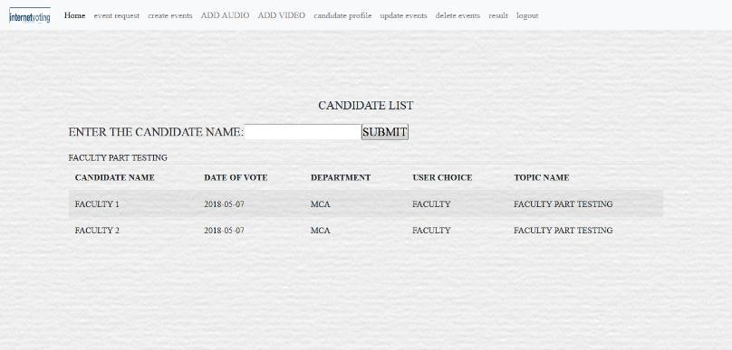

<!doctype html>

<html>

<head>

<meta charset="UTF-8">

<title>online portal</title>

<meta name="viewport" content="width=device-width, initial-scale=1, shrink-tofit=no">

<link rel="stylesheet" href="css/bootstrap.min.css" />

<link rel="stylesheet" href="css/bootstrap.css" />

<link rel="stylesheet" href="css/bootstrap-grid.css" />

<link rel="stylesheet" href="css/bootstrap-grid.min.css" />

<link rel="stylesheet" href="css/bootstrap.min.css" />

<link rel="stylesheet" type="text/css" href="style.css" />

</head>

<body>

<FORM ACTION="sercan.php" enctype="multipart/form-data" method="post" onsubmit="return validate()">

<div id="wrapper">

<div id="main">

<nav class="navbar navbar-expand-lg navbar-light bg-light navbar-left">

<a class="navbar-brand" href="#">

<img src="img/logo.png" width="80" height="30" class="d-inline-block align-top" alt=""> </a>

<button class="navbar-toggler" type="button" data-toggle="collapse" datatarget="#navbarSupportedContent" aria-controls="navbarSupportedContent" ariaexpanded="false" aria-label="Toggle navigation">

<span class="navbar-toggler-icon"></span>

</button>

<div class="collapse navbar-collapse" id="navbarSupportedContent">

<ul class="navbar-nav mr-auto">

<li class="nav-item active">

<a class="nav-link" href="#">Home <span class="sr-only">(current)</span></a>

</li>

<li class="nav-item">

<a class="nav-link" href="eventrequest.php">event request</a>

</li>

<li class="nav-item">

<a class="nav-link" href="CHOICECREATE.PHP">create events</a>

</li>

<li class="nav-item">

<a class="nav-link" href="adaudio.php">ADD AUDIO</a>

</li>

<li class="nav-item">

<a class="nav-link" href="advideo.php">ADD VIDEO</a>

</li>

<li class="nav-item">

<a class="nav-link" href="canpro.php">candidate profile</a>

</li>

<li class="nav-item">

<a class="nav-link" href="updateevent.php">update events</a>

</li>

<li class="nav-item">

<a class="nav-link" href="deleteevent.php">delete events</a>

</li>

<li class="nav-item">

<a class="nav-link" href="res.php">result</a>

</li>

<li class="nav-item">

<a class="nav-link" href="logout.php">logout</a>

</li>

</ul>

</div>

</nav>

<div class="hero">

<div class="container">

<div class="row align-items-center">

<div class="col-lg-12 col-md-12">

<TABLE CLASS="TABLE TABLE-STRIPED">

<TH><h1> ENTER THE CANDIDATE NAME:<INPUT TYPE="TEXT" NAME="can"><INPUT

TYPE="SUBMIT" VALUE="SUBMIT"></h1></TH>

<H1>CANDIDATE LIST</H1>

<table class="table table-striped">

<thead>

<tr>

<th scope="col">CANDIDATE NAME</th>

<th scope="col">DATE OF VOTE</th>

<th scope="col">DEPARTMENT</th>

<th scope="col">USER CHOICE</th>

<th scope="col">TOPIC NAME</th>

</thead>

<tbody>

<?php

include('connection.php');

SESSION_START();

$t=$_POST['TN'];

$sql="select * from candidates WHERE topic_name='$t'";

$res=mysql_query($sql); while($row=mysql_fetch_array($res))

{

$to=$row['topic_name'];

echo $to; echo "<tr>

<td>$row[can1name]</td>

<TD>$row[voting_date]</TD> <TD>$row[dept]</TD>

<TD>$row[user_choice]</TD>

<td>$row[topic_name]</TD>

</TR>";

ECHO " <TR>

<td>$row[can2]</td>

<td>$row[voting_date]</td>

<td>$row[dept]</td>

<td>$row[user_choice]</td> <td>$row[topic_name]</td>

</tr>";

}

$sql1="select * from candidates5 where topic_name='$t'";

$res1=mysql_query($sql1);

while($row1=mysql_fetch_array($res1))

{

echo " <tr> <td>$row1[can1]</td>

<td>$row1[voting_date]</td> <td>$row1[dept]</td>

<td>$row1[user_choice]</td> <td>$row1[topic_name]</td>

</tr>"; echo " <tr>

<td>$row1[can2]</td>

<td>$row1[voting_date]</td>

<td>$row1[dept]</td>

<td>$row1[user_choice]</td> <td>$row1[topic_name]</td>

</tr>";

echo " <tr>

<td>$row1[can3]</td>

<td>$row1[voting_date]</td>

<td>$row1[dept]</td>

<td>$row1[user_choice]</td>

<td>$row1[topic_name]</td>

</tr>"; echo " <tr>

<td>$row1[can4]</td>

<td>$row1[voting_date]</td>

<td>$row1[dept]</td>

<td>$row1[user_choice]</td> <td>$row1[topic_name]</td>

</tr>"; echo " <tr>

<td>$row1[can5]</td>

<td>$row1[voting_date]</td>

<td>$row1[dept]</td>

<td>$row1[user_choice]</td> <td>$row1[topic_name]</td>

</tr>";

}

?>

</tbody>

</table>

</div>

<script src="js/jquery.js"></script>

<script src="js/bootstrap.js"></script>

<script src="js/bootstrap.bundle.js"></script>

<script src="js/bootstrap.bundle.min.js"></script>

<script src="js/bootstrap.min.js"></script>

</body>

</html>

UPDATEEVENT.PHP

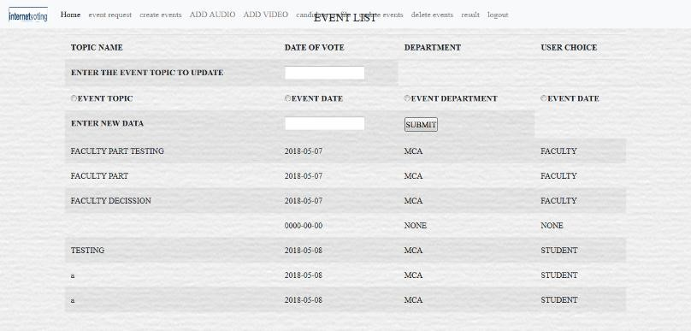

<!doctype html>

<html>

<head>

<meta charset="UTF-8">

<title>online portal</title>

<meta name="viewport" content="width=device-width, initial-scale=1, shrink-tofit=no">

<link rel="stylesheet" href="css/bootstrap.min.css" />

<link rel="stylesheet" href="css/bootstrap.css" />

<link rel="stylesheet" href="css/bootstrap-grid.css" />

<link rel="stylesheet" href="css/bootstrap-grid.min.css" />

<link rel="stylesheet" href="css/bootstrap.min.css" />

<link rel="stylesheet" type="text/css" href="style.css" />

</head>

<body>

<DIV CLASS="WRAPPER">

<DIV CLASS="main">

<FORM ACTION="sercan.php" enctype="multipart/form-data" method="post" onsubmit="return validate()">

<nav class="navbar navbar-expand-lg navbar-light bg-light navbar-left">

<a class="navbar-brand" href="#">

<img src="img/logo.png" width="80" height="30" class="d-inline-block align-top" alt="">

</a>

<button class="navbar-toggler" type="button" data-toggle="collapse" datatarget="#navbarSupportedContent" aria-controls="navbarSupportedContent" ariaexpanded="false" aria-label="Toggle navigation">

<span class="navbar-toggler-icon"></span>

</button>

<div class="collapse navbar-collapse" id="navbarSupportedContent">

<ul class="navbar-nav mr-auto">

<li class="nav-item active">

<a class="nav-link" href="#">Home <span class="sr-only">(current)</span></a>

</li>

<li class="nav-item">

<a class="nav-link" href="eventrequest.php">event request</a>

</li>

<li class="nav-item">

<a class="nav-link" href="CHOICECREATE.PHP">create events</a>

</li>

<li class="nav-item">

<a class="nav-link" href="adaudio.php">ADD AUDIO</a>

</li>

<li class="nav-item">

<a class="nav-link" href="advideo.php">ADD VIDEO</a>

</li>

<li class="nav-item">

<a class="nav-link" href="canpro.php">candidate profile</a>

</li>

<li class="nav-item">

<a class="nav-link" href="updateevent.php">update events</a>

</li>

<li class="nav-item">

<a class="nav-link" href="deleteevent.php">delete events</a>

</li>

<li class="nav-item">

<a class="nav-link" href="res.php">result</a>

</li>

<li class="nav-item">

<a class="nav-link" href="logout.php">logout</a>

</li>

</ul>

</div>

</nav>

</div>

<div class="hero">

<div class="container">

<div class="row align-items-center">

<div class="col-md-4 col-md-push-8">

<img class="img-fluid mb-3 mb-md-0" src="img/CANPRO.JPG" alt="" width="1024" height="860">

</DIV>

<div class="col-md-8 col-md-pull-4">

<TABLE><TR><TD>

<h1>

SELECT YOUR CHOICE

</H1>

<tr>

<th><A HREF="update.php">UPDATE EVENT</TH>

<TH><a href="update1.php">UPDATE CANDIDATES</TH>

</tr>

</table>

<script src="js/jquery.js"></script>

<script src="js/bootstrap.js"></script>

<script src="js/bootstrap.bundle.js"></script>

<script src="js/bootstrap.bundle.min.js"></script>

<script src="js/bootstrap.min.js"></script>

</body>

</html>

### UPDATE1.PHP

<!doctype html>

<html>

<head>

<meta charset="UTF-8">

<title>online portal</title>

<meta name="viewport" content="width=device-width, initial-scale=1, shrink-to-fit=no">

<link rel="stylesheet" href="css/bootstrap.min.css" />

<link rel="stylesheet" href="css/bootstrap.css" />

<link rel="stylesheet" href="css/bootstrap-grid.css" />

<link rel="stylesheet" href="css/bootstrap-grid.min.css" />

<link rel="stylesheet" href="css/bootstrap.min.css" />

<link rel="stylesheet" type="text/css" href="style.css" />

</head>

<body>

<FORM ACTION="updatework.php" enctype="multipart/form-data" method="post" onsubmit="return validate()">

<div id="wrapper">

<div id="main">

<nav class="navbar navbar-expand-lg navbar-light bg-light">

<a class="navbar-brand" href="#">

<img src="img/logo.png" width="80" height="30" class="d-inline-block align-top" alt="">

</a>

<button class="navbar-toggler" type="button" data-toggle="collapse" datatarget="#navbarSupportedContent" aria-controls="navbarSupportedContent" ariaexpanded="false" aria-label="Toggle navigation">

<span class="navbar-toggler-icon"></span>

</button>

<div class="collapse navbar-collapse" id="navbarSupportedContent">

<ul class="navbar-nav mr-auto">

<li class="nav-item active">

<a class="nav-link" href="#">Home <span class="sr-only">(current)</span></a>

</li>

<li class="nav-item">

<a class="nav-link" href="#"></a>

</li>

<li class="nav-item dropdown">

<a class="nav-link dropdown-toggle" href="#" id="navbarDropdown" role="button" data-toggle="dropdown" aria-haspopup="true" aria-expanded="false"> event creation

</a>

<div class="dropdown-menu" aria-labelledby="navbarDropdown">

<a class="dropdown-item" href="eventmanage.php">manage events</a>

<a class="dropdown-item" href="adaudio.php">add audio</a>

<a class="dropdown-item" href="advideo.php">add video</a>

<div class="dropdown-divider"></div>

</div>

</li>

<li class="nav-item dropdown">

<a class="nav-link dropdown-toggle" href="#" id="navbarDropdown" role="button" data-toggle="dropdown" aria-haspopup="true" aria-expanded="false"> candidate views

</a>

<div class="dropdown-menu" aria-labelledby="navbarDropdown">

<a class="dropdown-item" href="canli.php">candidate list</a>

<a class="dropdown-item" href="canpro.php">candidate profile</a>

<div class="dropdown-divider"></div>

</div>

</li>

<li class="nav-item dropdown">

<a class="nav-link dropdown-toggle" href="#" id="navbarDropdown" role="button" data-toggle="dropdown" aria-haspopup="true" aria-expanded="false"> update

</a>

<div class="dropdown-menu" aria-labelledby="navbarDropdown">

<a class="dropdown-item" href="updateevent.php">update events</a>

<a class="dropdown-item" href="upchoice.php">delete events</a>

<a class="dropdown-item" href="adreq.php">admin request</a>

<div class="dropdown-divider"></div>

</div>

</li>

<li class="nav-item">

<a class="nav-link" href="res.php">result</a>

</li>

<li class="nav-item">

<a class="nav-link" href="logout.php">logout</a>

</li>

</ul>

</div>

</nav>

<div class="hero">

<div class="container">

<div class="row align-items-center">

<div class="col-md-12">

<br><br><br><br><br><br><br><br><br><br><br><br><br><br><br><br><br><br><br><br

<table class="table table-striped">

<h1>CANDIDATE LIST</H1>

<thead>

<tr>

<th scope="col">CANDIDATE NAME</th>

<th scope="col">CANDIDATE DETAILS</th>

<th scope="col">DATE OF VOTE</th>

<th scope="col">DEPARTMENT</th>

<th scope="col">USER CHOICE</th>

<th scope="col">TOPIC NAME</th>

</thead>

<tbody>

<?php

include('connection.php');

$sql="select * from candidates";

$sql1="select * from candidates5";

$res1=mysql_query($sql1);

$res=mysql_query($sql);

while($row=mysql_fetch_array($res))

{

echo " <tr>

<td>$row[can1name]</td>

<td>$row[can1details]</td>

<TD>$row[voting_date]</TD> <TD>$row[dept]</TD>

<TD>$row[user_choice]</TD>

<td>$row[topic_name]</TD> </TR>";

ECHO " <TR>

<td>$row[can2]</td>

<td>$row[can2details]</td>

<td>$row[voting_date]</td> <td>$row[dept]</td>

<td>$row[user_choice]</td>

<td>$row[topic_name]</td>

</tr>";

}

while($row1=mysql_fetch_array($res1))

{

echo " <tr> <td>$row1[can1]</td>

<td>$row1[can1det]</td>

<td>$row1[voting_date]</td> <td>$row1[dept]</td>

<td>$row1[user_choice]</td>

<td>$row1[topic_name]</td>

</tr>";

echo " <tr>

<td>$row1[can2]</td>

<td>$row1[can2det]</td>

<td>$row1[voting_date]</td>

<td>$row1[dept]</td>

<td>$row1[user_choice]</td>

<td>$row1[topic_name]</td>

</tr>"; echo " <tr>

<td>$row1[can3]</td>

<td>$row1[can3det]</td>

<td>$row1[voting_date]</td>

<td>$row1[dept]</td>

<td>$row1[user_choice]</td>

<td>$row1[topic_name]</td>

</tr>"; echo " <tr>

<td>$row1[can4]</td>

<td>$row1[can4det]</td>

<td>$row1[voting_date]</td>

<td>$row1[dept]</td>

<td>$row1[user_choice]</td>

<td>$row1[topic_name]</td>

</tr>"; echo " <tr>

<td>$row1[can5]</td>

<td>$row1[can5det]</td>

<td>$row1[voting_date]</td>

<td>$row1[dept]</td>

<td>$row1[user_choice]</td>

<td>$row1[topic_name]</td>

</tr>";

}

?>

</tbody>

<TR>

<th>ENTER CANDIDATE NAME TO UPDATE</th>

<th><INPUT TYPE="TEXT" NAME="UCAN"></TH>

<th><INPUT type="Radio" name="r" value="cname">candidate name</th>

<th><INPUT type="Radio" name="r" value="cdetails">candidate details</th>

<TH>ENTER NEW DATA</TH>

<TH><INPUT TYPE="TEXT" NAME="NUCAN"></TH>

<TH><INPUT TYPE="SUBMIT" VALUE="SUBMIT"></TH>

</TR>

</table>

</div>

<script src="js/jquery.js"></script>

<script src="js/bootstrap.js"></script>

<script src="js/bootstrap.bundle.js"></script>

<script src="js/bootstrap.bundle.min.js"></script>

<script src="js/bootstrap.min.js"></script>

</body>

</html>

### DELETE.PHP

<!doctype html>

<html>

<head>

<meta charset="UTF-8">

<title>online portal</title>

<meta name="viewport" content="width=device-width, initial-scale=1, shrink-tofit=no">

<link rel="stylesheet" href="css/bootstrap.min.css" />

<link rel="stylesheet" href="css/bootstrap.css" />

<link rel="stylesheet" href="css/bootstrap-grid.css" />

<link rel="stylesheet" href="css/bootstrap-grid.min.css" />

<link rel="stylesheet" href="css/bootstrap.min.css" />

<link rel="stylesheet" type="text/css" href="style.css" />

</head>

<body>

<DIV CLASS="WRAPPER">

<DIV CLASS="main">

<FORM ACTION="DELETE.PHP" enctype="multipart/form-data" method="post" onsubmit="return validate()">

<nav class="navbar navbar-expand-lg navbar-light bg-light navbar-left">

<a class="navbar-brand" href="#">

<img src="img/logo.png" width="80" height="30" class="d-inline-block align-top" alt="">

</a>

<button class="navbar-toggler" type="button" data-toggle="collapse" datatarget="#navbarSupportedContent" aria-controls="navbarSupportedContent" ariaexpanded="false" aria-label="Toggle navigation">

<span class="navbar-toggler-icon"></span>

</button>

<div class="collapse navbar-collapse" id="navbarSupportedContent">

<ul class="navbar-nav mr-auto">

<li class="nav-item active">

<a class="nav-link" href="#">Home <span class="sr-only">(current)</span></a>

</li>

<li class="nav-item">

<a class="nav-link" href="eventrequest.php">event request</a>

</li>

<li class="nav-item">

<a class="nav-link" href="CHOICECREATE.PHP">create events</a>

</li>

<li class="nav-item">

<a class="nav-link" href="adaudio.php">ADD AUDIO</a>

</li>

<li class="nav-item">

<a class="nav-link" href="advideo.php">ADD VIDEO</a>

</li>

<li class="nav-item">

<a class="nav-link" href="canpro.php">candidate profile</a>

</li>

<li class="nav-item">

<a class="nav-link" href="updateevent.php">update events</a>

</li>

<li class="nav-item">

<a class="nav-link" href="deleteevent.php">delete events</a>

</li>

<li class="nav-item">

<a class="nav-link" href="res.php">result</a>

</li>

<li class="nav-item">

<a class="nav-link" href="logout.php">logout</a>

</li>

</ul>

</div>

</nav>

<div class="hero">

<div class="container">

<div class="row align-items-center">

<div class="col-md-4 col-md-push-8">

<img class="img-fluid mb-3 mb-md-0" src="img/CANPRO.JPG" alt="" width="1024" height="860">

</DIV>

<div class="col-md-8 col-md-pull-4">

<TABLE><TR><TD>

<h1>EVENT LIST</H1>

<table class="table table-striped">

<thead>

<tr>

<th scope="col">TOPIC NAME</th>

<th scope="col">DATE OF VOTE</th>

<th scope="col">DEPARTMENT</th>

<th scope="col">USER CHOICE</th>

</tr>

</thead>

<tbody>

<?php

include('connection.php');

$sql="select * from decission_making";

$res=mysql_query($sql);

while($row=mysql_fetch_array($res))

{

echo " <tr>

<td>$row[topic_name]</TD>

<TD>$row[voting_date]</TD>

<TD>$row[con_dept]</TD>

<TD>$row[con_cat]</TD>

</TR>";

}

?>

</tbody>

<TR>

<th>ENTER THE EVENT TOPIC TO DELETE</th>

<th><INPUT TYPE="TEXT" NAME="DEL"></TH>

<TH><input type="submit" class="btn btn-info" value="DELETE"></TH>

<TH><a href="DELETEALL.PHP" class="btn btn-info" role="button">DELETE ALL</a></a>

</TR>

</table>

</table>

<script src="js/jquery.js"></script>

<script src="js/bootstrap.js"></script>

<script src="js/bootstrap.bundle.js"></script>

<script src="js/bootstrap.bundle.min.js"></script>

<script src="js/bootstrap.min.js"></script>

</body>

</html>

</html>

CALCULATION.PHP

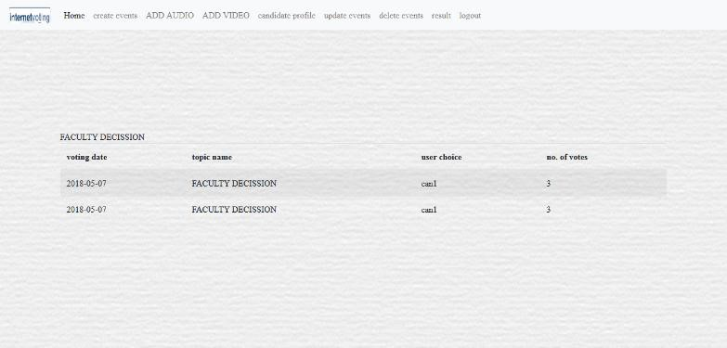

<!doctype html>

<html>

<head>

<meta charset="UTF-8">

<title>online portal</title>

<meta name="viewport" content="width=device-width, initial-scale=1, shrink-tofit=no">

<link rel="stylesheet" href="css/bootstrap.min.css" />

<link rel="stylesheet" href="css/bootstrap.css" />

<link rel="stylesheet" href="css/bootstrap-grid.css" />

<link rel="stylesheet" href="css/bootstrap-grid.min.css" />

<link rel="stylesheet" href="css/bootstrap.min.css" />

<link rel="stylesheet" type="text/css" href="style.css" />

<link rel="stylesheet" type="text/css" href="STYLE1.CSS" />

</head>

<body>

<div id="main">

<nav class="navbar navbar-expand-lg navbar-light bg-light navbar-left">

<a class="navbar-brand" href="#">

<img src="img/logo.png" width="80" height="30" class="d-inline-block align-top" alt="">

</a>

<button class="navbar-toggler" type="button" data-toggle="collapse" datatarget="#navbarSupportedContent" aria-controls="navbarSupportedContent" ariaexpanded="false" aria-label="Toggle navigation">

<span class="navbar-toggler-icon"></span>

</button>

<div class="collapse navbar-collapse" id="navbarSupportedContent">

<ul class="navbar-nav mr-auto">

<li class="nav-item active">

<a class="nav-link" href="#">Home <span class="sr-only">(current)</span></a>

</li>

<li class="nav-item">

<a class="nav-link" href="CHOICECREATE.PHP">create events</a>

</li>

<li class="nav-item">

<a class="nav-link" href="adaudio.php">ADD AUDIO</a>

</li>

<li class="nav-item">

<a class="nav-link" href="advideo.php">ADD VIDEO</a>

<li class="nav-item">

<a class="nav-link" href="canpro.php">candidate profile</a>

</li>

<li class="nav-item">

<a class="nav-link" href="updatevent.php">update events</a>

</li>

<li class="nav-item">

<a class="nav-link" href="deleteevent.php">delete events</a>

</li>

<li class="nav-item">

<a class="nav-link" href="res.php">result</a>

</li>

<li class="nav-item">

<a class="nav-link" href="logout.php">logout</a>

</li>

</ul>

</div>

</nav>

</div>

</div>

<div class="hero"> <?php

session_start();

### CONNECTION.PHP

$tnm=$_POST['tn'];

$_SESSION['tn']=$tnm;

$sql="select can1 from canvote where can1=1 and topic_name='$tnm'"; $ctr=0;

$res=mysql_query($sql); while($row=mysql_fetch_array($res))

{

$ctr++;

}

$sql1="select can2 from canvote where can2=1 and topic_name='$tnm'";

$ctr1=0;

$res1=mysql_query($sql1); while($row1=mysql_fetch_array($res1))

{

$ctr1++;

}

if($ctr>$ctr1)

{

?>

<h2>Winner</h2>

<?php

include('connection.php');

$sql="select can1name,can1picture,voting_date from candidates where topic_name='$tnm'";

$res=mysql_query($sql);

while($row=mysql_fetch_array($res))

{

$cn=$row['can1name'];

$cp=$row['can1picture']; $d=$row['voting_date'];

mysql_query("insert into

winner(topic_nam,canname,canpicture) values('$tnm','$cn','$cp')");

?>

<center><img src="<?php echo $cp ?>" height="90" width="90"><br> candidate name:

<?php

echo $cn;

}

}

else if($ctr<$ctr1)

{

include('connection.php');

$sql="select can2,can2picture from candidates where topic_name='$tnm'";

$res=mysql_query($sql);

while($row=mysql_fetch_array($res))

{

$cn=$row['can2'];

$cp=$row['can2picture']; $d=$row['voting_date'];

mysql_query("insert into

winner(topic_nam,canname,canpicture) values('$tnm','$cn','$cp')");

?>

<center><img src="<?php echo $cp ?>" height="90" width="90"><br> candidate name:

<?php

echo $cn;

}

}

else if($ctr==$ctr1)

{

include('connection.php');

$sql="select * from candidates where topic_name='$tnm'";

$res=mysql_query($sql);

while($row=mysql_fetch_array($res))

{

$cn1=$row['can1name'];

$cp1=$row['can1picture'];

$cn=$row['can2'];

$cp=$row['can2picture']; $d=$row['voting_date'];

echo "its a tie";

?>

<center><br><img src="<?php echo $cp1 ?>" height="90" width="90"><br> candidate name:

<?php

echo $cn1;

?>

<br><img src="<?php echo $cp ?>" height="90" width="90"> candidate name:

<?php

echo $cn;

}

}

else

{

echo "invalid request";

}

?>

<br><?php echo $tnm ?></center>

<table class="table table-striped">

<thead>

<tr>

<th scope="col">voting date</th>

<th scope="col">topic name</th> <th scope="col">user choice</th>

<th scope="col">no. of votes</th>

</tr>

</thead>

<?PHP

$res1=mysql_query("select topic_nam,canname,count(*) as counts from winner where topic_nam='$tnm' group by canname");

while($row1=mysql_fetch_array($res1))

{

echo

"<tr><td>$d</td><td>$row1[topic_nam]</td><td>$row1[canname]</td><td>$row1[count s]</td></tr>";

}

$res=mysql_query("select voting_date,topic_name,user_choice,count(*) as counts from canvote1 where topic_name='$tnm' group by user_choice" ); while($row=mysql_fetch_array($res))

{

$c=$row['counts'];

$uc=$row['user_choice']; $v=$row['voting_date'];

echo "<tr>

<td>$row[voting_date]</td>

<td>$row[topic_name]</td> <td>$row[user_choice]</td>

<td>$row[counts]</td>

</tr>";

}

$res=mysql_query("select voting_date,topic_name,user_choice,count(*) as counts from canvote1 where topic_name='$tnm' group by user_choice" ); while($row=mysql_fetch_array($res))

{

$c=$row['counts'];

$uc=$row['user_choice']; $v=$row['voting_date'];

echo "<tr>

<td>$row[voting_date]</td>

<td>$row[topic_name]</td> <td>$row[user_choice]</td>

<td>$row[counts]</td>

</tr>";

}

mysql_query("insert into winner1(voting_date,topic_name,user_choice,total_votes) values('$v','$tnm','$uc','$c')");

?>

</table>

</div>

</body>

</html>

### LOGOUT.PHP

<?php session_start(); echo "Successfully Logged Out"; session_destroy(); header("location:user.html")

?>

### REQEVEVT.PHP

<!

doctype html

>

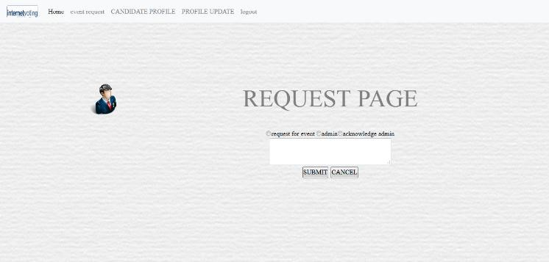

<html>

<head>

<meta charset="UTF-8">

<title>online portal</title>

<meta name="viewport" content="width=device-width, initial-scale=1, shrink-tofit=no">

<link rel="stylesheet" href="css/bootstrap.min.css" />

<link rel="stylesheet" href="css/bootstrap.css" />

<link rel="stylesheet" href="css/bootstrap-grid.css" />

<link rel="stylesheet" href="css/bootstrap-grid.min.css" />

<link rel="stylesheet" href="css/bootstrap.min.css" />

<link rel="stylesheet" type="text/css" href="style.css" />

<link rel="stylesheet" type="text/css" href="STYLE1.CSS" />

</head>

<body>

<form action="checkusr.php" method="post" onsubmit="return validate()">

<div id="wrapper">

<div id="header">

<div id="main">

<nav class="navbar navbar-expand-lg navbar-light bg-light navbar-left">

<a class="navbar-brand" href="#">

<img src="img/logo.png" width="80" height="30" class="d-inline-block align-top" alt="">

</a>

<button class="navbar-toggler" type="button" data-toggle="collapse" datatarget="#navbarSupportedContent" aria-controls="navbarSupportedContent" ariaexpanded="false" aria-label="Toggle navigation">

<span class="navbar-toggler-icon"></span>

</button>

<div class="collapse navbar-collapse" id="navbarSupportedContent">

<ul class="navbar-nav mr-auto">

<li class="nav-item active">

<a class="nav-link" href="#">Home <span class="sr-only">(current)</span></a>

</li>

<li class="nav-item">

<a class="nav-link" href="reqevent.php">event request</a>

</li>

<li class="nav-item">

<a class="nav-link" href="canpro.php">CANDIDATE PROFILE</a>

</li>

<li class="nav-item">

<a class="nav-link" href="logout.php">logout</a>

</li>

</ul>

</div>

</nav>

<div id="menu"></div>

<div id="content">

<div class="hero">

<div class="container">

<div class="row profile">

<div class="col-md-3">

<div class="profile-slider">

<div class="profile-user-pic">

<img src="img/fac.png" class="imgr-responsive img-circle" height="80%" width="80%">

</div>

<div class="profile-user-title">

<div class="profile-user-name">

<?php

include('connection.php');

SESSION_START();

$user=$_SESSION["uid"];

$res=mysql_query("select * from student_registration where student_registration_no='$user'");

while($row=mysql_fetch_array($res))

{

$fn=$row['Student_Name'];

$ln=$row['student_lastname'];

$mn=$row['Mobile_No'];

$d=$row['Dept'];

$c=$row['category'];

$yr=$row['year']; $sc=$row['s_category'];

echo $fn; echo $ln."<br>";

?>

</div>

<div class="profile-user-job">

<?php

echo "Mobile No:".$mn."<br>"; echo "Dept:".$d."<br>"; echo "year of joining:".$yr."<br>";

echo "category".$c."<br>";

}

?>

</div>

</div>

</div>

</div>

<div class="col-md-9">

<H2>REQUEST PAGE</H2>

<center>

<center> <H1> request for event:</H1><input type="radio" name="r" value="event">request for event<br>

<TEXTAREA ROW="10" COLS="40" NAME="REQ" id="CAN1"></TEXTAREA>

<TD COLSPAN="2"><br><CENTER><INPUT TYPE ="submit" VALUE="SUBMIT">

<INPUT TYPE ="reset" VALUE="CANCEL"></CENTER></TD>

</div>

</body>

</html>

### STUDENTLOGIN.PHP

<!doctype html>

<html>

<head>

<meta charset="UTF-8">

<title>online portal</title>

<meta name="viewport" content="width=device-width, initial-scale=1, shrink-tofit=no">

<link rel="stylesheet" href="css/bootstrap.min.css" />

<link rel="stylesheet" href="css/bootstrap.css" />

<link rel="stylesheet" href="css/bootstrap-grid.css" />

<link rel="stylesheet" href="css/bootstrap-grid.min.css" />

<link rel="stylesheet" href="css/bootstrap.min.css" />

<link rel="stylesheet" href="css/bootstrap-reboot.css" />

<link rel="stylesheet" href="css/bootstrap-reboot.min.css" />

<link rel="stylesheet" type="text/css" href="style.css" />

</head>

<body>

<FORM ACTION="checkstuser.php" method="post">

<div id="wrapper">

<div id="header">

<div id="main">

<nav class="navbar navbar-expand-lg navbar-light bg-light">

<a class="navbar-brand" href="index.html">

<img src="img/logo.png" width="80" height="30" class="d-inline-block align-top" alt="">

</a>

<button class="navbar-toggler" type="button" data-toggle="collapse" datatarget="#navbarSupportedContent" aria-controls="navbarSupportedContent" ariaexpanded="false" aria-label="Toggle navigation">

<span class="navbar-toggler-icon"></span>

</button>

<div class="collapse navbar-collapse" id="navbarSupportedContent">

<ul class="navbar-nav mr-auto">

<li class="nav-item active">

<a class="nav-link" href="#">Home <span class="sr-only">(current)</span></a>

</li>

<li class="nav-item">

<a class="nav-link" href="user.html">user</a>

</li>

<li class="nav-item">

<a class="nav-link" href="status.php">status</a>

</li>

<li class="nav-item">

<a class="nav-link" href="contactus.html">contact us</a>

</li>

</ul>

</div>

</nav>

<div id="menu"></div>

<div id="content">

<div class="hero">

<div class="banner-content col-lg-7 col-md-12">

<div class="login-box">

<img src="img/sstd.png" class="sstd">

<h1>student login</h1>

<form action="checkstuser.php" method="post" onsubmit="return validate()"> <p>college id :</p>

<INPUT TYPE="TEXT" NAME="UID" ID="ud" placeholder="enter collegeid">

<p>Password :</p>

<INPUT TYPE ="PASSWORD" NAME="PWD" ID="pd" placeholder="enter password">

<INPUT TYPE ="submit" VALUE="LOGIN">

<INPUT TYPE ="reset" VALUE="CANCEL">

<p><center>registered not yet<A HREF="registration.php">CLICK

HERE</A></center></p>

</form>

</div>

</div>

</div>

</div>

<div id="comment"></div>

<div id="footer"></div>

</div>

</body>

</html>

Working principle:

This project has been developed for the the survey and polling systems. Admin gets login by valid username and password. Admin can see the request send by the students or faculty. Admin can also create events manually. Admin can view all the details and can allow special user to create event. Admin verifies the details of the members and declares the result.

The student portion will allow students to participate in the polling system for election of the common college election for the college welfare such as selecting class representative, college general secretary etc. they are also allowed to participate in the college survey and decision making system for the college.

The faculties’ portion will also work in the same process but will allow the faculty members only in the survey and college committee selection procedures.

Features of this management system:

* Easy to read, understand and navigate.
* It is completely secure
* It can be completely controlled by a single person, i.e. admin.
* This system is easily compatible with most of the browsers such as Google Chrome, Mozilla Firefox, and Microsoft Internet Explorer etc.
* It is very interactive and saves time.
* Reduces paper works.

Future scope of the work:

* The development process of this system can be easily followed by adding new features to the site as and when the end user requires. This might also lead to a possible enhancement of flexibility between the modules.
* In future we may add a member portal where members can give feedback about an event.
* Some visualized features may be added which can be more interactive to the members of the system.
* The system can be developed in such a way that its existing features will also be provided after.

Conclusion:

Now a days a good Online Portal for Survey and Polling System is a gateway to the college management and its works. People get influenced by look and easy to access features. So it is imperative that a college, be it a small scale, medium scale or a large scale will always look for a good computerised survey taking system. With technologies on the go touching people’s lives anywhere and everywhere, a good Online Portal for Survey and Polling system acts as a bonus to these modern world institutions.

Bibliography:

Books:

* PHP: The Complete Reference Author: Steven Holzner

Publisher: McGraw Hill Education

* Head First PHP and MySQL

Author: Michael Morrison, Lynn Beighley

Publisher: Shroff-O’Reilly

Websites:

• [www.w3schools.com](http://www.w3schools.com/)

### • www.getbootstrap.com

• [www.youtube.com](http://www.youtube.com/)